Spring 2022 Senior Design 1
Live Bolt Smart Lock

Department of Electrical and Computer Engineering
University of Central Florida
60 Page Draft
Group 22
March 25, 2022

Linda Anyosa - Electrical Engineering
Mohamed Faizel - Computer Engineering
Andrew O’Reilly - Electrical Engineering
Joel Shaw - Computer Engineering

1. Executive Summary
2. Project Description
2.1 Project Motivation and Goals
2.2 Objectives 2
2.3 Requirements Specifications 2
2.4 Quality of House Analysis 5
3. Research Related to Project Definition 6
3.1 Existing Similar Projects and Products 6
3.1.1 Ring Doorbell 6
3.1.2 Google Nest Doorbell 7
3.1.3 Yale Lock Integration 7
3.1.4 August Smart Lock 8
3.1.5 Nuki Smart Lock 9
3.2 Computation and Control Device 9
3.2.1 Arduino Line 10
3.2.1.1 Arduino Uno 10
3.2.1.2 Arduino Mega 10
3.2.2 Raspberry Pi Line 10
3.2.2.1 Raspberry Pi Model 3B+ 10
3.2.2.2 Raspberry Pi Model 4 11
3.2.3 Texas Instruments MSP430 Line 11
3.2.3.1 MSP430FR6989 11
3.2.3.2 MSP430G2553 11
3.2.4 ESP Wi-Fi Module Line 12
3.2.4.1 ESP32 12
3.2.4.2 ESP8266 12
3.3 Sensors 12
3.3.1 Voice/Phrase Recognition 12
3.3.2 Face Recognition 13
3.3.2.1 Computer Vision 13
3.3.2.2 Intel RealSense ID 13
3.3.2.3 Xbox Kinect 14
3.3.2.4 Smart Phone Face ID 14
3.3.3 Near-Field Communication 15
3.3.4 Infrared Sensor 15
3.3.5 Security Camera 15
3.3.6 Number Pad 16
3.4 Power Sources 16
3.4.1 Solar Panel 16
3.4.2 AC Power 16
3.4.3 Conventional Battery Pack 17
3.5 Locking Methods 17
3.5.1 Electric Strike Locks 17
3.5.2 Magnetic Locks 17
3.5.3 Dead-bolt Locks 18
3.6 Feedback System 18
3.6.1 LED/Buzzer on Physical Device 18
3.6.2 Application Notifications 18
3.7 Parts Selection 19
3.7.1 Computation and Control Device 19
3.7.2 ReSpeaker 4-Microphone Array 19
3.7.3 Smart Phone Face Identification 19
3.7.4 HiLetgo NFC Module 20
3.7.5 HC-SR501 Infrared Sensor 20
3.7.6 ArduCam Security Camera 20
3.7.8 Rechargeable Battery Packs 20
3.7.9 Traditional Dead-Bolt Lock 21
3.7.10 Feedback System 21
4. Related Standards and Realistic Design Constraints 21
4.1 Standards 21
4.1.1 Wi-Fi Standards (802.11) 21
4.1.2 Bluetooth Standards (802.15.1) 22
4.1.3 RFID Standards 22
4.1.4 NFC Standards 23
4.1.5 Measurement Standards 23
4.1.6 Deadbolt Lock Standards 23
4.1.7 Face Recognition Standards 24
4.1.8 Programming Best Practices 25
4.1.9 Apple App Store and Google Play Store Standards 26
4.1.10 Design impact of relevant standards 27
4.2 Realistic Design Constraints 28
4.2.1 Knowledge constraints 28
4.2.2 Economic constraints 29
4.2.3 Time constraints 30
4.2.4 Environmental constraints 32
4.2.5 Energy constraints 32
4.2.6 Social constraints 32
4.2.7 Political constraints 33
4.2.8 Ethical constraints 33
4.2.9 Health and Safety constraints 34
4.2.10 Sustainability constraints 34
4.2.11 Manufacturability constraints 34
5. Initial Design Architectures and Related Diagrams 35
6 Software Design Details 38
6.1 Initial Design Architecture 38
6.2 Mobile Application Pros and Cons 39
6.2.1 LAMP Stack 39
6.2.2 MERN Stack 40
6.2.3 MEAN Stack 40
6.3 UX Design 40
6.4 Preliminary UI Design 41
6.5 Logo Design 42
6.6 Bluetooth Pairing 43
6.6.1 Android Bluetooth APIs 43
6.6.2 react-native-bluetooth-serial Plugin 43
6.6.2 react-native-ble-manager Plugin 44
6.6.3 Classic or Low Power Mode? 44
6.7 Development Environment 44
6.8 App Store Publishing Process 45
6.9 Google Play Store Publishing Process 45
6.10 Mobile Stack Technologies 46
6.10.1 MERN Stack Reasoning 46
6.10.2 JavaScript 46
6.10.3 Ajax 46
6.10.4 jQuery 47
6.10.5 JSON 47
6.10.6 JSX 47
6.10.5 JSON Web Token 48
6.11 Database Structure 48
6.11.1 MongoDB Syntax 49
7. Hardware Design Details 49
7.1 Electronics Placement 49
7.1.1 Dead Bolt Lock Prototype 49
7.1.2 Security Prototype 51
7.2 Power Distribution 53
7.3 3D Printing 54
7.4 Summary of Design 55
8. Printed Circuit Board Integrated Schematics 55
8.1 PCB Terminology 55
8.2 PCB CAD Software 57
8.2.1 KiCad 57
8.2.2 EAGLE 57
8.2.3 CAD Software Decision 57
8.3 PCB Vendor and Assembly 57
9. Project Prototype Testing Plan 58
9.1 Hardware Test Environment 58
9.2 Hardware Specific Testing 58
9.3 Software Test Environment 58
9.4 Software Specific Testing 58
10. Administrative Content 58
10.1 Milestone Discussion 58
10.2 Budget and Finance Discussion 59
Appendices 1
Appendix A – References 1
References 1
Appendix B - Datasheets (if needed) 2
Appendix C – Software (if needed) 2
Appendix D – Other 2

1. Executive Summary
It’s every homeowner’s dream to discover an all-in-one security system with affordability to the consumer’s access. With a growing and competitive market of security systems, there is a lack of cost flexibility of how much security would be provided to the consumer. What makes this project different than other security systems is it incorporates home monitoring and entry available through a phone application or at door entrance. This will be accomplished by designing an Android/IOS application to pair with the module and grant access to home monitoring and real-time automated lock to the homeowner deadbolt. Hence the introduction of the project, Live Bolt.

Building the mechanism and harnessing the compatibility to a phone application would require having components in mind. To share the data between the hardware and software of the system, a Raspberry pi and Arduino Uno will satisfy these requires. Although these components don’t consist of the whole system, it would bring together the data exchanged to control the open/close lock and push notifications for home monitoring. Other hardware and software design choice will be elaborated further given the research done to execute our goal.

After developing the ideal design, we’ll overcome realistic design constraints which are factors that’ll alter the systems performance. This is including wireless range access for entrance, weather suitable, aesthetic presentation of the system, and battery life implementation. Ethical challenges from the construction of the system would also have to align with the path of preventing security breach. External data will be for citational and referenced purposes only to keep the consumers privacy secured.

2. Project Description

2.1 Project Motivation and Goals
The main motivation for creating this project was from our individual experience in package theft. In an instance that a package has been labeled delivered but, not within the front door or close radius of a home can be bothersome to a customer. A package is ideally something of a need or want from a consumer. Why not monitor/ report any front door activity through a security system? In this question, we came with the idea of building a security system to monitor and allow front door access to delivery workers with a one-pin code to reliably deliver the package within a home. Although this idea grants entrance, there must be an automated lock to open and close the door for a home. Therefore, we decided to expand upon this project to include variety of access control for the consumer. It’ll logically make sense to not only have a locking mechanism for delivery worker but to include forms of entrances for the consumers own usage. We want to introduce a software application to harness the numeral access control to a consumer at their own usage of a cell phone. Additionally, this motivation of creating an application would challenge and utilize the team’s software skills in building a reliable security system that could potentially be used in industry.

Our goal is to create a reliable low-cost security system with multiple methods of home/ package safety for the consumers of tomorrow. We want to challenge the current security market by creating a new set up with an app and hardware systems interface. In doing so, we would keep the system as user-friendly as possible while keeping it as secure as possible. We will achieve these goals by creating a lightweight security system that can be placed in desired monitoring areas (e.g., home, shed, garage), distributing power to electronic hardware, and establishing a connection between the lock and phone application. It is also a goal for us to keep costs of hardware low while maintaining quality to make this product accessible to low-income families.

2.2 Objectives
Our main objective for the project is to design an innovative security and integrated lock system that combines the features of available systems in the market into one unified package. To have our project stand out, we plan to offer the most features in access control and home monitoring for the best price while ensuring optimal quality, functionality, and aesthetics to our customers home and style. How we plan to target these objectives is by researching existing home security and locking systems in the market. In access control we will also scope upon versatility about how a homeowner would like to open their front door. In security measures, we’d like to research forms of home monitoring and reaction to keeping a property secured. While these two would create most of the hardware for the project, we need to make it available through a mobile application for the customers convince. Objectives to execute that action would be to adhere to commonly held design standards to usability, have an always-online internet connection, and include tools like VoiceOver or TalkBack to incorporate accessibility. Additionally, we’d like to make this system small and applicable to every home door. Creating a compact/portable system will be our priority when engineering the smart lock design through choice of buying electrical/mechanical parts. From the team’s knowledge and capabilities, we will ensure thorough testing that we will deliver a fully functioning product that our customers will love.

2.3 Requirements Specifications
For the design of our Live Bolt product, we’d like to incorporate a mixture of all of the following research we’ve conducted on these home security devices. The list below in Table 1, Table 2, Table 3, Table 4 will include requirement specifications on hardware and software execution of our senior design project.

Table 1: Requirement specifications for Security System Features
SECTION | REQUIREMENT | SOLUTION | VERIFICATION
Security System (SS)
SS.1 | Notifying motion sense to consume | Controlled through an Arduino Uno (IR motion detector) | Integrate sensors to application
SS.2 | Home monitoring | 5 Megapixel, 2592 x 1944 image resolution, 1080p video resolution | Viewable video stream sent from camera
SS.3 | Time stamps unlock attempts | Sensing | Send message to user when attempts are made
SS.4 | Single use PIN numbers for guests/ delivery workers | Application interface for one-use code | Send a text message to guest with one-use code
SS.5 | Alarm system | Integrate LEDs and buzzers trigger when multiple attempts are failed in succession | Send message to app when alarm system is triggered

Table 2: Requirement specifications for Access Control Features
SECTION | REQUIREMENT | SOLUTION | VERIFICATION
Access Control (AC)
AC.1 | Accessibility to consumer with ease | Android/iOS application | Publish to App Store/Google Play Store
AC.2 | Application unlocking system | 4-to-6-digit PIN number, unlock remotely via mobile application, face detection through application, NFC | Notification sent when door is locked/unlocked
AC.3 | Hardware unlocking system | Voice recognition, PIN code access | Door is able to be opened without interference

Table 3: Requirement specifications for Application Features
SECTION | REQUIREMENT | SOLUTION | VERIFICATION
Application (A)
A.1 | Simple and user-friendly UI/design | Adhere to commonly held design standards for usability | Use a variety of methods to test code, including end-to-end tests
A.2 | Live Bolt must be always-online to mobile application | Use a React API to monitor internet connection | Display message to user if connection is lost
A.3 | Accessibility | Tools like VoiceOver or TalkBack | Integrate TTS in user interface

Table 4: Requirement specifications for Design Features
SECTION | REQUIREMENT | SOLUTION | VERIFICATION
Design (D)
D.1 | Locking door system | High torque servo to turn lock, 10 kg*cm with about 170 degrees range of motion. 3D Printed cover for dead-bolt turn knob | Servo is successfully able to turn the knob cover enough to lock/unlock door every time
D.2 | Weather-proof casing | Housing made of weather-proof material like plastic or metal | Product able to withstand varying states of weather while maintaining functionality
D.3 | Long battery life | Implement low power mode to conserve battery when not in use. Allow for easy swapping of battery packs. Implement battery monitoring system (BMS) | Device can withstand weeks to months of use on a single charge

2.4 Quality of House Analysis
Before constructing Live Bolt, we created a house of quality for our system to ensure the highest quality of our product between engineering requirements and marketing requirements. The House of quality matrix, shown in Table 5, allows us to identify the level of importance and devise a strategy on how to achieve our requirements. Before beginning to identify the importance for each requirement, creating a legend for the correlation, relationship, and improvement of direction for our system is indicated below the table. In our table we highlighted what wad stated in our goals such as portability, security protection, sensors, battery life, etc., in engineering requirements. Now this must align with customer requirements within the quality or product and user preferences. This would market to customers with the understanding that our team puts their usability/ flexibility first. With the weight column ranging from 1-10, we identify cost and user interface as top priority to make it accessible and user-friendly as possible to be purchased by a larger audience. Engineering and customer requirements go together when finding the direction of improvement needed to be done in our system. As engineers, the house of quality outlines ways we can improve our design why considering a consumer desire. With Live Bolt, we intent to maximize improvement although intuitively we could overcome engineering constraints.
Table 5: House of Quality for Live Bolt
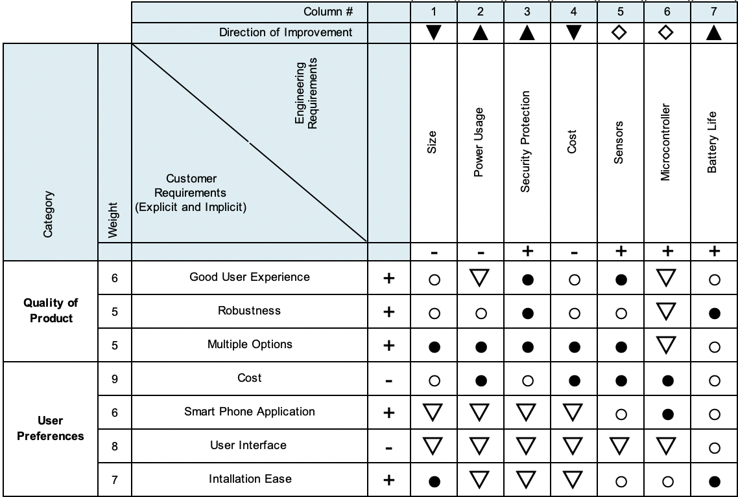
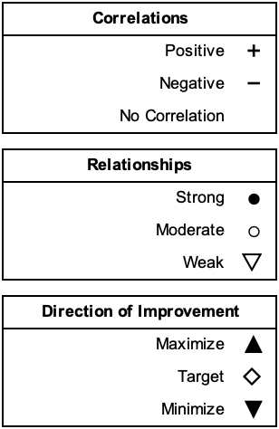

3. Research Related to Project Definition

3.1 Existing Similar Projects and Products
Home security and access control integrated in homes today are at an abundant. With this growing market, we would like to formally research about existing products and seek improvement in their systems. This research will inspire the design for Live Bolt.

3.1.1 Ring Doorbell
Ring video doorbell provides variety in the sense that there are different features of home monitoring installation: wired, battery powered, and bundles leading to solar power or security included. Ring doorbell is customized to reach as many consumers as possible no matter the circumstance of the front door, hence the variety of options. Additionally, with Ring’s growing reputation, they provide flexibility to consumers with different option in monitoring their home. From buying one of their products, it includes motion detection; application integration of notifying the consumer of front door activity; and see, hear, speaking que to visitors in real time.

There are some downsides to including one of the Ring video doorbell to one’s home. One main reason being that there are so many options to choosing a reliable doorbell into one’s home. With that comes variety of options for how to determine one’s monitoring. Many options include variety but could be overwhelming to a customer. Additionally, to use one of their products it includes a monthly subscription plan from additionally purchasing the device. Another problem with ring doorbell is that it requires a strong WiFi connection that essentially must be provided by the consumer. Information exchange between the device and application will be hindered if not provided with a strong network. This research is great notes on how to make our Live Bolt system enhanced and more available to the public. We would like to obtain features that the Ring doorbell incorporates like motion sensing and application availability while subtraction the subscription plan. Live Bolt differs since there’ll also be access control of entering a home through the application. We also take reference of the Ring application to apply towards our application user interface.

3.1.2 Google Nest Doorbell
Another product similar to Live Bolt is the Google Nest Doorbell; Google’s attempt at a home security monitoring system. It has many features such as a camera, doorbell, sound detection and familiar face detection. Moreover, the setup is wired to configure with an existing doorbell system or can run wirelessly. Google has made it possible to integrate the doorbell with the rest of the Google Nest environment. Features the Nest Doorbell that Live Bolt will include are the camera monitoring system, face detection, and app integration. However, unlike the Nest Doorbell, Live Bolt allows for multiple unlock methods and gives the user an unlock log report through the application interface. It additionally differs in that it is a door locking security system compared to Nest Doorbell which only offers video and audio monitoring. Through this comparison between the two systems, we can see clearly that Live Bolt is the more cost-effective option than the Nest Doorbell. The Nest Doorbell only offers Doorbell monitoring of your existing system while Live Bolt steps up the security of your system.

3.1.3 Yale Lock Integration
Google Nest Doorbell has the capability to interface with the Yale electronic door lock. The Yale lock is a keyless smart lock, similar to Live Bolt, that incorporates a digital keypad. Yale allows for a passcode you can give to people you trust that you can disable at any time. It also offers self-locking features, and the ability to lock/unlock through a phone application. With Live Bolt, we will combine features from both the Nest Doorbell and Yale Lock to enhance safety and security in a single product.

3.1.4 August Smart Lock
The August Lock is a Smart Lock system like many of the others we researched which integrates directly onto an existing deadbolt system. It does require some unscrewing to integrate however August does include videos to guide users through the process. One benefit is that the August lock doesn’t prevent you from using your traditional key so that option is still available to use. It includes an Auto Lock and Auto Unlock feature which allows for geofencing to be used to determine if the user is leaving or heading toward the home. It also allows for the ability to use a smartwatch to lock and unlock the door without having to bring out your phone. The lock has a mobile app which allows many features including controlling multiple locks, inviting other people to manage the locks, temporary guest keys, an activity timeline, and additional security with the option of mobile bio authentication through the smartphone. These are useful features and many of which we are including in our Live Bolt system to strengthen it’s security and usability. Additionally, the August Lock does have multiple models to choose allowing customers to choose what locking system works best for them. The pricing of their most costly locking system, the Wi-Fi Smart Lock, comes to 229 USD which is comparable to the wired version of the Google Nest Doorbell. Additionally, if customers end up getting a cheaper model and want to add the August Wi-Fi Bridge to get all the features the total cost is the same as or less than the cost of the Wi-Fi Smart Lock.

There are downsides to August’s Smart Locks. For one the newest generation released by August, although smaller and less bulky than the previous generation, has a smaller battery life. The 3rd generation had a battery life ranging from 6 to 12 months where the current 4th generation has a battery life from 3 to 6 months. Additionally, the batteries for the 4th generation are not the standard AAA or AA batteries and are instead CR123A batteries. These batteries are both more difficult to find and expensive to purchase than normal replaceable batteries. A drawback from August lock comes to auto unlocking connectivity. Auto lock works well for when the lock is able to connect to bluetooth easily. However, it doesn’t work as well when it fails to connect before the User reaches the door making them wait. Another issue can happen when the door unlocks but the user takes too long to open it. If the user lives in an area where they must climb stairs or use an elevator the door can unlock and then relock before the user reaches. This also becomes a convenience issue for the user as it could force them to use their key or have to unlock the lock again from their phone. Another issue with the August lock and most other smart locks is the lack of RFID and Near-Field Communication (NFC). The August Lock already supports smartwatch integration and allowing for NFC unlocking would be a useful feature. It would eliminate the need to take out your phone or open the app allowing for the user's device to be held close to the lock to open. With Live Bolt we plan on incorporating both RFID and NFC to give users more options to unlock the system and ease of access.

3.1.5 Nuki Smart Lock
The Nuki Smart Lock is another product that caught our attention as we were researching for our project. It is a smart lock system that directly integrates onto an existing locking system. There is no need for screwdrivers or other tools to install the system as it uses a physical key to lock and unlock the door as if a person was turning the lock themselves. This way of integrating the system allows for it to be compatible with many door locks. Nuki has recently revamped their product line with the 3.0 series offering a normal and pro model. Both share many of the same features aside from the pro having a Wi-Fi module in addition to its Bluetooth module, and a rechargeable battery where the normal uses 4 AA batteries. In our Live Bolt system, we will be providing only one product so users will not have to worry about product tradeoffs like with Nuki’s products. Nuki also provides a smartwatch integration in addition to their mobile app allowing for you to unlock your door from your smartwatch. They also allow the ability to create and assign digital keys to family and friends which is similar to a feature we will include in the Live Bolt system.
We did see downsides to the Nuki Smart Lock 3.0 series which we have taken note of in designing the Live Bolt system. The first is that not all locks work with Nuki’s system so customers will need to check their compatibility guide before purchasing a lock. Another is that for the normal lock model any Wi-Fi actions the user wants to do will need the Nuki Bridge, one of Nuki’s many accessories. The Nuki Bridge has a Wi-Fi module allowing for the base model lock to connect to Wi-Fi. The Pro model comes with this feature in the box. Without the Wi-Fi module in the Pro or Nuki Bridge with the base model users lose out on features like Smart assistants, and Remote management. This significantly limits the users experience and these are features we plan to implement into Live Bolt without the need for accessories. Another downside of the Nuki is cost. The base model is 149 € which is 169 USD and the Pro is 249 € which is 305 USD. This is already a high cost for the system, and it doesn’t take into account the price of the many accessories Nuki offers to enhance the Smart Lock experience. From a Keypad to open your door with a code to the Door Sensor which enhances the sensing of the system, Nuki offers many accessories which can feel vital to a better experience. Lastly, the Nuki system does not include a camera for both models. Lacking this feature makes seeing who is at your door impossible however Nuki does include an activity report in the app for monitoring. This is limited however to Nuki products that can connect to Wi-Fi. The Live Bolt system will have a camera for viewing activity outside the door allowing for the user to know what is always happening.

3.2 Computation and Control Device
To execute our objective for Live Bolt, there’ll need to be control and wireless communication between the servo and/or sensors to the application. Choosing the right control device will play a large role to our design; therefore, we will dive into the various options to what control devices are on the market and their characteristics for delivering performance.

3.2.1 Arduino Line
The Arduino line of microcontrollers operate from an ATmega chip. The specific model of Arduino varies depending on the application. The two that we have narrowed down to are the Arduino Uno and Arduino Mega. Both operate at 5V, are programmed via USB A/B; however, they have a lot more differences than similarities that will be outlines below.

3.2.1.1 Arduino Uno
The Arduino Uno is a smaller microcontroller, with a size of 2.7 inches by 2.1 inches. Since it is physically smaller, it has fewer pins, with 14 digital pins and 6 analog pins. The Arduino Uno also has a 16MHz Atmega328p processor and 32kB of flash memory. These microcontrollers can be purchased in the range of $20.

3.2.1.2 Arduino Mega
The Arduino Mega is physically much larger than the Arduino Uno, at 4 inches by 2.1 inches. Since it is longer it has more pins, 54 digital pins and 16 analog pins, 50 more pins than the Uno. It has a 16MHz ATmega2560 processor and 256kB of flash memory. These models are usually around $42.

3.2.2 Raspberry Pi Line
The Live Bolt System will need a more powerful processor to host the application and process voice recognition. The Raspberry Line of computation devices would easily serve this need. A Raspberry Pi is essentially a small computer and can run an operating system and programs. The two Raspberry Pi boards we will look at are the Model 3B+ and the newer Model 4. Both are 3.35 inches by 2.20 inches, house 40 GPIO pins, and operate off 5V. They are also capable of Wi-Fi natively.

3.2.2.1 Raspberry Pi Model 3B+
The Model 3B+ is an older model, but not obsolete by any means. With a 1.5GHz Quad-Core Broadcom BCM2837B0 processor and 1GB DDR2 RAM, the Model 3B+ can handle multiple processes at once. It has one HDMI port, four USB 2.0 ports, and ethernet. It is also powered through either a micro-USB or a GPIO pin header to supply power. These models usually cost around $35.

3.2.2.2 Raspberry Pi Model 4
The Model 4 is the successor to the Model 3B+. It has improvements to the processor, now a 1.5 GHz Broadcom BCM2711. The RAM has also been updated to DDR4, with options for 1GB, 2GB, and 4GB. The power is now supplied through a GPIO pin or USB-C and there are two micro-HDMI ports rather than one full HDMI port. Two of the four USB 2.0 ports were also replaced with two USB 3.0 ports. The 2GB model costs about $45.

3.2.3 Texas Instruments MSP430 Line
Texas Instrument microcontrollers offers one of the best analog in the industry with affordability as its best option. The MSP430 line is 16-bit MCU including flexible, integrated analog components, such as ADCs, DACs, and Op-amps; Integrated LCD controllers for displaying information; and devices with USB2.0 for communication with PC or application updates. As undergraduate engineering students at UCF, our classes have introduced two known microcontrollers from TI: MSP430FR6989 and MSP430G2553.

3.2.3.1 MSP430FR6989
The MSP430FR6989 provides ultra-low-power FRAM platform uniquely embedded and a holistic ultra-low-power system architecture to increase performance at lowered energy budgets. Additionally, the MSP430FR6989 includes features of a 16-Bit RISC architecture up to 16-MHz Clock, integrated LCD driver with 320 segments, and multifunction input/output ports. A few parameters from this microcontroller (MC) include a 128 kB non-volatile memory, 2 KB of RAM, 12-bit SAR ADC, No USB port, 2 I2Cs and 4 SPI. Due to high demand, these are currently out of stock in the TI website, but alternative websites offer this microcontroller from $24 - $50.

3.2.3.2 MSP430G2553
The MSP430G2553 is like the FR6989 MC from the fact that it is also an ultra-low-power missed signal MC with a built in 16-bit timer. It has low supply-voltage range of 1.8 V to 3.6 V. The G2553 is a 16-but RISC architecture and a basic clock module configuration with a 24 capacitive touch enabled I/O pins. There is no LCD driver or USB port in this MC. Note that an online purchase will equate to the price of just a chip but, the whole controller would summarize to $40.

3.2.4 ESP Wi-Fi Module Line
The ESP line of microcontrollers are low-cost controllers with wireless capabilities that are great for internet-of-things and home automation projects, like the Live Bolt. If we choose to include Wi-Fi into the microcontrollers of the Live Bolt system, it might be better to opt for an ESP device over another microcontroller since Arduino and MSP430 do not have Wi-Fi natively. Both modules come with Wi-Fi and are programmed via the Arduino integrated development environment (IDE).

3.2.4.1 ESP32
The ESP32 is a very powerful development board with a 160MHz clock frequency, 34 GPIO pins, 16 PWM channels, SRAM, and Flash RAM. These models also include a touch sensor, temperature sensor, and hall effect sensor. It operates on the HT40 40Mhz spectrum of a 2.4GHz Wi-Fi band. One major difference between the ESP32 and ESP8266 is that the ESP32 includes Bluetooth 4.2 and Bluetooth 5.0 with Bluetooth Low Energy (BLE). It is 54.6 mm x 27.94 mm x 13 mm and costs anywhere from $6 to $12.

3.2.4.2 ESP8266
The ESP8266 is less powerful than the ESP32 but is still very useful for the application of this project. It has an 80MHz clock frequency, 17 GPIO pins, and 8 PWM channels. It lacks any Bluetooth capabilities and operates on the HL20 20MHz spectrum of the 2.4GHz Wi-Fi band. It also lacks the touch sensor, temperature sensor, and hall effect sensor that is present on the ESP32. Since it lacks some features, it is smaller and cheaper. Coming in at 48 mm x 26 mm x 13 mm and $3 to $6.

3.3 Sensors
The application for including sensors within our system is to include variety in access control for unlocking a door and provide home monitoring. We will detail the options for choices that could be provided in Live Bolt.

3.3.1 Voice/Phrase Recognition
Since the Raspberry Pi is processing the voice recognition software, a microphone is needed that is compatible with the Raspberry Pi. The microphone must also produce clean voice captures to be used in Artificial Intelligence applications. The voice input will be processed, and the program will determine whatever was said. If the word is a registered trigger word, the system will unlock the door. It would be best to incorporate multiple microphones into an array to get the best voice capture.

3.3.2 Face Recognition
For increased security, we would like to include some form of biometric facial recognition on the Live Bolt system. This can be implemented in a variety of ways, which are outlined below. Our main goal is to have a system that is as accurate as possible at detecting a registered face and rejecting unregistered faces. Overall cost, size and computing time can be greatly impacted depending on the method that is decided.

3.3.2.1 Computer Vision
The Live Bolt will have a feature that unlocks the door when a registered face is detected. There are a few ways to go about this. The first method considered was to use a simple webcam and incorporate computer vision image processing methods through machine learning. This method would require a very large dataset of every person using the face identification features. The datasets would need to consist of at least 1000 photos of the person to start reliably detecting. It would require even more photos at different angles and light levels to increase consistency. Once a dataset is created, the photo captured during the unlock attempt would be passed through a convolutional neural network and eventually compared to the dataset. The output of the network would be a prediction if the subject is the same one as in the training dataset. Ideally, an accuracy of 99.5% or greater would be given every time for a positive match, and as close to 0% as possible for a negative match. Due to the limitations of computing hardware and convolutional neural network training times, this method isn’t the most reliable, so it would have to be combined with another form of access like the keypad, to ensure safety.

3.3.2.2 Intel RealSense ID
The second possibility that was researched was 3D mapping technologies like Intel RealSense ID and Xbox Kinect. 3D mapping, or photogrammetry mapping, allows for something in real life to be measured and projected onto a screen in the form of a 3D map or model. The measurement consists of taking small bits of data from different points around whatever you are mapping to create a depth map. One key advantage to 3D mapping for facial recognition, besides for more reliable recognition, is that the 3D map creates depth of someone’s face. This keeps someone from simply showing a photo or model of someone else to the camera and have that be accepted as the target face. The process of using a photo of someone to trick a facial recognition system is known as spoofing.
Intel has developed a technology called RealSense ID that utilizes 3D mapping techniques to rapidly authenticate someone’s face. They have all-in-one products that are ready to be used in a variety of applications straight out of the box, such as their F455 product. They also provide their architecture for custom designs in their F450 product. The features of the F455 will be focused on for the sake of this project. The F455 is 32.5mm x 62mm x 11mm and has a viewing angle of 56° × 78°. It needs a Window, Linux, or Android operating system to operate. These devices have a 1:1,000,000 false acceptance rate (0.0001%), a 99.76% true acceptance rate, and a spoof acceptance rate of less than 0.1%. This makes them extremely secure and fit for a security lock application. Both models come with a system on the chip (SOC) which is an integrated circuit for computing and processing. They are also equipped with two 1920x1080 resolution cameras, IR sensor, 3D dot projector, and a light for more accurate capture. The Intel RealSense ID F455 is available for about $105.

3.3.2.3 Xbox Kinect
Microsoft has developed a product called Kinect for their line of Xbox gaming consoles that also utilize 3D mapping technology, for a gaming application rather than a facial recognition application. Since it is designed for gaming, it is meant more for detecting the body’s of players for motion-based video games. The camera is equipped with a 30 frames-per-second 640x480 pixel resolution color camera and a 320x240 pixel resolution depth camera. The cameras also have a 57° × 43° viewing angle. The lower resolution isn’t best for catching finer details, like what would be on a person’s face. The way it is able to track bodies is by creating a virtual skeleton of up to two players on the screen. These skeletons have 20 joints per player and can track when the player moves one of their joints, like their legs or arms. The Xbox 360 Kinect is 76.2mm x 279.4mm x 76.2mm. The module costs about $20 used.

A new version of the Kinect has been released for the newer Xbox One console and has an updated 1920 x 1080 pixel resolution 30 frames-per-second color camera and 512 x 424 pixel resolution depth camera that are able to track up to six active players. The newer model also has 26 joints that it tracks, rather than 20. It is smaller than the original Kinect, with a size of 66.8mm x 248.92mm x 66mm and it costs approximately $80.

3.3.2.4 Smart Phone Face ID
The most well-known method of Face Recognition is the methods used on modern cell phones to unlock them. This section will mainly focus on the Apple iPhone Face ID and Android Face Authentication HIDL. They work similarly to the 3D depth scanner of the Intel RealSense ID technology. Since most people have a phone with face identification capabilities, this would be a good way to save space on our module while still maintaining quality face recognition. 90% of smart phones are expected to include some form of biometric facial recognition by 2024 [1]. They are also advantageous due to being able to detect someone’s face with minor differences form the training dataset, such as if they were wearing sunglasses or if they grew a beard. Both platforms also have open-source application programming interfaces (APIs) for app developers to program them. Since this method incorporates the user’s phone, there would be little to no cost associated with it. This would in turn keep the overall cost of the product lower, while also keeping the product size smaller since it would not need to house larger cameras or processors for face detection.

3.3.3 Near-Field Communication
Near-Field Communication (NFC) is a popular use in today technology of contact-less communication from using radio frequency. This technology is used to primarily to exchange data within two devices through a touch gesture. The NFC controller needs to be connected with antenna transmit and receive all NFC communication frames to the NFC Forum Device. Using the NFC forum device will be an integration of using software in our application for Live Bolt and making sure it can recognize the chip that’ll be placed in our design.

Since NFC is very flexible in operating in different modes, the most ideal application of NFC to Live Bolt would be through Host Card Emulation. Due to our idea for making it easy for the user to enter their home, having an NFC controller forward contact-less commands to the Device Host.

3.3.4 Infrared Sensor
The infrared sensor is integral to the security system because it will help to identify is someone has entered in front of the Live Bolt lock. Any Infrared sensor that is compatible with Arduino or Raspberry Pi would be fine for our application. Ideally it would have 2-5 feet of detecting distance. Using an infrared sensor for motion detection rather than another method like computer vision or ultrasonic sensing is beneficial because it can detect changes in temperature that the other sensors cannot, and therefore can tell is a human or animal is being detected. An ultrasonic sensor would trigger whenever anything gets into range, such as leaves or other debris.

3.3.5 Security Camera
The Live Bolt system will include a security camera for the customer to view a live feed of the area in front of their door. The security camera has two main requirements: a high Field-of-View and good resolution. This way it can view the largest area with the most clarity. Since most cameras are compatible with Raspberry Pi models, we needed to compare USB cameras, like webcams, to integrated camera modules that connect to the Raspberry Pi via ribbon cables. A secondary requirement for the camera is how much space it will take up. It will need to be mounted to the outdoor module of the Live Bolt, so it would be better for it to be as small as possible while maintaining Field-of-View and resolution quality.

3.3.6 Number Pad
The number keypad will be used by guests to unlock the door with a one-time code that is 4 to 6 digits. If there was a single code that always unlocked the door, those keys would begin to fade and make it easy for an intruder to guess the code. The main requirement for this keypad is for it to be weatherproof, mainly from rain since it will be on the outside module, so it must be made of waterproof plastic or metal. An alphanumeric pad could be useful for added security; however, a numeric pad would also be fine for the scope of this project.

3.4 Power Sources
All the computational devices we have identified operate off 5V. This means we will need a reliable power source that can output 5V for a very long time. To identify the main source of power to operate our system, we will look at a variety of options to execute its functionality.

3.4.1 Solar Panel
Powering our system from solar panels was an early goal that we wanted to research more. Since solar panels do not output their peak voltage 100% of the time, a battery pack would also need to be included to keep the system running. A panel rated for at least 5V would be required. A possible issue with using solar panels is that the lock system might be shaded from the sun, making any solar panel useless. Solar panels also use up more space, and we would like to keep the system as compact as possible.

3.4.2 AC Power
The most reliable method to power the system would be to tie it to the 120V, 60Hz, AC power used to supply power to the rest of the home. However, this would mean that when the house loses power for any reason, the lock would also lose power. Working with 120V is also potentially dangerous for the engineers designing the system, and the customers installing it. Ease of installation is something we are working hard towards and having to tie the system to a house power system may not be safe for someone who is unexperienced. This method would also not be plausible for someone living in an apartment complex.

3.4.3 Conventional Battery Pack
Including a battery pack seems like the best method to supply power to the system. Since both Arduino and the Raspberry Pi operate off 5V, a pack of at least 5V is required. Most batteries are more or less, but not exactly 5V. This means that the battery supply will most likely need to be stepped up or down to 5V to meet power consumption needs. A major issue with batteries is that they will inevitably run out of charge and the system will lose power. We would like to make the battery packs easily swappable and rechargeable so customers can always have power to their system. Rechargeable AA batteries typically output 1.25V, so including four in series would provide us with the 5V we need. Since we want to include rechargeable batteries, something like a Lithium Polymer battery would not be the best choice for the engineers or the customer These types of batteries are very easy to mishandle by someone without experience and can lead to fire, smoke, or explosions if over or undercharged.

3.5 Locking Methods
Included in our objective, we want to make sure that there is a clear sense of security to the homeowner, hence the reason for including a good locking method. Below are the options we’ve discussed as a team that would be liable for improving security when designing Live Bolt.

3.5.1 Electric Strike Locks
Arguably the most important feature of this product is how it will physically lock a door and keep unwanted visitors out. The main methods that were considered for this project were electric strike locks, magnetic locking mechanisms, and traditional dead-bolt locks.

Electric strike locks and magnetic locks are both typically incorporated into doors of most institutional and commercial buildings, like schools or shops. An electric strike lock operates very similarly to a dead-bolt lock, except that instead of a human turning the bolt, an electric impulse causes the bolt to strike into place. A benefit of the electric strike lock is that once it is locked, it no longer needs an electrical signal and can keep the door from opening.

3.5.2 Magnetic Locks
Magnetic locks feature an electromagnet on the doorframe and a piece of metal attached to the door. When the door is closed, the magnet and metal will make contact. Then, if an electrical signal is sent through the magnet, it will activate and attract the metal piece, causing the door to remain locked closed. The electrical signal for both locks can be sent via multiple methods but are typically sent from a key card reader or keypad. The magnetic lock needs a constant source of power to remain locked, or else the door will be able to be opened.

3.5.3 Dead-bolt Locks
A traditional dead-bolt lock is what is seen in most homes. It operates by having the user manually turn a thumb knob located on the inside of the home. When this knob is turned, the bolt is struck into place, blocking the door from being opened. To automate this task for the purpose of the Live Bolt system, having a servo motor turn the bolt would be best because it allows the door to be locked or unlocked remotely without the need for a person to physically be at the door. Most commercial smart locks on the market opt for a method of having customers unscrew the doorknob off their door and attach a unit that houses the servo motor to the inner mechanisms of the lock. Another method requires the thumb knob to be fitted with a cover. A servo motor will then turn this cover, and therefore the knob, to unlock the door. A downside to this is that not every door thumb knob is the same shape and size, making the cover hard to replicate for different doors.

3.6 Feedback System
In creating Live Bolt, we want to ensure that there’s home monitoring within the vicinity of the home. From that outcome, it’s only logical to include a feedback system to the homeowner about any undisclosed guests within their property. This will help enhance the responsiveness and security of our system. The following feedback systems will be considered to take place in our design.

3.6.1 LED/Buzzer on Physical Device
One tactical way to prevent intruders from entering a home is through a reactive system. When an alarm goes off it typically does resign well within the situation. In our design, we essentially want to incorporate a buzzer/ flashing LEDs onto the physical device when entering through force. That way the intruder is indicated that our system is aware that there is entry and will notify the homeowner. These reactive systems may result in the intruder not entering the home which would be in favor of the customer. Visual deterrents such as these can help prevent a potential break through immediate feedback which will prove useful in our system.

3.6.2 Application Notifications
An added feature we’d like to incorporate is to provide notification through an application of someone unlocking the door, movement within the door entrance, and whether there’s been a force entrance. This will be done with the use of our sensors cooperating with the raspberry pi. This information will then be relayed to our mobile application for the user to evaluate. The user interface will have the option of being sent notification of the following home indication. With including mobile notifications, we hope to provide security to our consumers knowing that their homes will be monitored 24/7.

3.7 Parts Selection
After considering all the possible parts listed above, we have narrowed down what we think would best fit the design we have created. All of the parts chosen are listen below with their technical specifications. A breakdown of each components cost and where they were sourced is located in Table 10: Bill of Materials.

3.7.1 Computation and Control Device
It was decided that for the computational device, that a mix of using a Raspberry Pi and Arduino would provide the best combination of processing power. The Raspberry Pi is responsible for interfacing with the microphone for phrase detection, the security camera for video streaming, and hosting the phone application. The Arduino will process the NFC scanner input, the number pad input, and the passive infrared sensor. The output for the Arduino will be the security system, which consists of an LED and buzzer. Additionally, an ESP8266 module will be used on the inside unit to take data from the microcontrollers wirelessly and control the servo motor.

3.7.2 ReSpeaker 4-Microphone Array
For the voice capture device, we opted for the Seeed Studio ReSpeaker 4-Microphone Array. This product is designed for all Raspberry Pi models. It has four microphones, one in each corner of the board. This allows for a higher quality sample to be collected and used by the Raspberry Pi for phrase detection. This board is based on the AC108 quad-channel analog-to-digital converter (ADC) for high quality voice capturing.

3.7.3 Smart Phone Face Identification
Due to cost, computing, and size constraints, it makes the most sense to utilize the Face Identification hardware that is already built into most user’s cell phones. This will mean that most of work that goes into this section will be done through the smart phone application. Both iPhone and Android have open-source libraries that can be used to include the face recognition features of their platforms on our application.

3.7.4 HiLetgo NFC Module
The HiLetgo PN532 NFC kit is made up of a key card, key ring, and the actual NFC module that supports NFC/RFID reading and writing. It operates at 5V for I2C and UART communication, and 3.3V for SPI communication. The module is very small and can easily be incorporated into the final product.

3.7.5 HC-SR501 Infrared Sensor
The Stemedu HC-SR501 PIR Motion Sensor was chosen for the infrared sensor because it is a passive infrared sensor. This means that it can detect changes in temperature in its viewing area to see if a human or animal is in view. Passive infrared sensors are the most-used type of motion detector for security applications so this will be easily integrated into the final design. When someone enters its viewing area, it will output a high voltage level. After they leave, it will go back to a low voltage output. This sensor features an option to adjust the delay time and block time. Delay time is how long after someone leaves its sensing area that it will remain outputting a high voltage before outputting a low voltage. Block time refers to the amount of time after going back to a low voltage before it can be triggered and set to a high voltage again. The delay time can range from 0.5 seconds to 200 seconds and the block time can range from 0 seconds to over 100 seconds. These delays are adjusted via potentiometers on the board itself, which eliminates the need for any programming with a microcontroller. This sensor offers a range of about 5 meters and a viewing angle of about 100 degrees or less.

3.7.6 ArduCam Security Camera
The biggest requirement for the camera is to have a small form factor while retaining enough quality to be a good choice for security applications. The ArduCam is a camera module that interfaces with any Raspberry Pi module via the 15-pin ribbon cable on the top of most Raspberry Pis. The ArduCam offers 1080-pixel resolution at 30 frames-per-second video quality and a viewing angle of 54 degrees by 41 degrees.

3.7.8 Rechargeable Battery Packs
We have opted to go with rechargeable battery packs to power each module of the design. We have decided to include rechargeable AA batteries in these packs. The technical specifications such as how many batteries in each pack and how much power they will produce will be discusses further in section 7.2 Power Distribution.

3.7.9 Traditional Dead-Bolt Lock
To keep the installation as simple as possible, it was decided to keep the traditional deadbolt design on the door and instead have a servo motor turn the thumb turn that sets/unsets the dead bolt in place. The servo motor that was chosen has a torque of 10 kg*cm and can rotate up to 170 degrees. Typically a servo motor with at least 180 degrees turn radius is desirable, but since we only need to turn the lock 90 degrees to lock/unlock it, 170 degrees is more than enough.

3.7.10 Feedback System
The way the system provides feedback to the user will be in two ways. The first method will be by indicators on the physical system. If an attempt to unlock the door fails, a buzzer will beep and an LED will flash to indicate that the attempt was unsuccessful. The second method will be via the phone application. When a attempt to unlock is made, it will send a notification to the application and indicate whether the attempt was successful or not.

4. Related Standards and Realistic Design Constraints

4.1 Standards
Within the area of Engineering Design and project creation, there are several standards to follow. These standards are important because they directly affect the way we design our Live Bolt system and the technologies we will use. Our Live Bolt system will utilize a few of these standards as it operates. We will need to adhere to these standards when including Wi-Fi, Bluetooth, RFID, and NFC technologies in the Live Bolt system.

4.1.1 Wi-Fi Standards (802.11)
Originally, the first standard for Wi-Fi was created in 1997 by the Institute of Electronics Engineers (IEEE). It was called IEEE 802.11 and had a network bandwidth of only 2 Mbps. This is very slow compared to the most recently accepted Wi-Fi 6 standard, also known as 802.11ax, which can support up to 10 Gbps. Since the creation of the 802.11 standard there have been many Wi-Fi standard iterations which each have their own advantages and disadvantages. As a result of this just because a standard has been approved by IEEE does not mean that it may be the best in every situation. As such the Wi-Fi standard we choose to use will be taken into careful consideration when we design the Live Bolt system.

As mentioned before the most recent Wi-Fi standard that was approved was Wi-Fi 6 back in 2019 by IEEE. However, this is not the Wi-Fi standard that will be used primarily in our system. We will be using a Raspberry Pi 4 in our system which uses the 802.11ac standard or Wi-Fi 5. This standard supports simultaneous connections on both 5 GHz and 2.4 GHz Wi-Fi devices. It also boasts a bandwidth of at most 1300 Mbps when using the 5 GHz connection and 450 on the 2.4 GHz. [14]

4.1.2 Bluetooth Standards (802.15.1)
Bluetooth or IEEE 802.15.1 was originally first standardized by IEEE like Wi-Fi. It was first introduced in 1998 and has since had its standard management transferred to the Bluetooth Special Interest Group (SIG). This group manages Bluetooth standards which manufacturers must follow if they want to include the technology in their devices.

Currently the only devices that will be utilizing Bluetooth in the Live Bolt Smart Lock system will be our Raspberry Pi 4 and a smart phone connected to our system through the app. The Raspberry Pi 4 uses Bluetooth 5 technology. Bluetooth 5 was released on December 6th, 2016 and introduced many improvements over the past generation. Bluetooth 5 provides support for Bluetooth Low Energy, or BLE, which is a subset of Bluetooth 4.0 technology that is aimed at supporting low power applications. Some of the new features of Bluetooth 5 includes options to double the speed while reducing the range and quadrupling the range at the cost of the data transmission. [17]

4.1.3 RFID Standards
RFID is a technology that uses electromagnetic fields to uniquely identify items. A typical RFID system involves the interaction between RFID tags and readers. We will be using an RFID in the Live Bolt system as a possible method to unlock the lock. There are many regulations and standards that are in place for RFID. These guidelines are in place to protect people and animals from harm that certain frequencies can cause.

There is not a central organization that manages RFID communication. Instead, there are several industries and organizations that have set their own standards for RFID communications. Additionally, each country can set its own rules for the frequency bands allowed for RFID communication. These bands are also known as the ISM, Industrial Scientific and Medical, bands on the electromagnetic spectrum. These are a portion of radio wave bands laid out on the spectrum reserved specifically for scientific, industrial, and medical purposes. We will carefully consider the various standards as we complete our design for the Live Bolt Smart Lock.

4.1.4 NFC Standards
NFC is a similar technology to RFID. It is a communication protocol set that allows two devices to communicate over a small distance, roughly 4 centimeters. NFC technologies are mainly used to facilitate contactless payment systems. However, in the Live Bolt system it will be used as an authentication technology for unlocking the lock.

The actual standards for NFC communication are based on similar standards to RFID. These standards include ISO/IEC 14443, ISO/IEC 18000-3, FeliCa, and those defined by the NFC Forum. These standards deal primarily with identification, proximity, and contact card regulations in use with NFC. ISO/IEC 14443, and ISO/IEC 18000-3 are important NFC standards as the first deals with the way identification cards can store information. The second deals with the way RFID communication can interface with NFC technology.

We will be using the HiLetgo PN532 Module kit for both our NFC and RFID communications. It supports reading and writing for both technologies. Several cards and standards work with the kit such as ISO/IEC 14443-4 cards, FeliCa cards, and Innovision Jewel cards. The kit uses I2C, SPI, and High Speed UART for communication. [16]

4.1.5 Measurement Standards
To keep the design process of the project consistent, we would like to note that our design will keep in the international System of Units (SI). This choice was determined because it used universally in technical and scientific research to avoid confusion when converting between units. This would help those unfamiliar with the imperial system since it’s less popularly used. Specifically, we would like to keep all set measurements in design to millimeters (mm) when obtaining dimensions.

4.1.6 Deadbolt Lock Standards
Every lock needs a locking mechanism, and the Live Bolt system is no different. The locking mechanism we will be using for our project will be a deadbolt lock. Deadlocks, like many other tools we will be using, have standards in place that will assist us in our design.

There are a few different ways deadbolt locks can be configured. These include the Single Cylinder Deadbolt, Double Cylinder Deadbolt, One-Sided Deadbolt with Outside Trim, and One-Sided Deadbolt Without Outside Trim. A single cylinder deadbolt is a two-sided lock where the outside side has a key slot to turn, and the inside part of the lock has a thumb turn. With the double cylinder deadbolt there is a key slot on both sides of the lock allowing a key to be used from the inside and outside of the door. A one-sided deadbolt with outside trim involves a plate being placed on the outside of the lock with a thumb turn on the inside of the lock. This allows the lock to be opened from the inside only. A one-sided deadbolt without outside trim is a configuration where there is nothing on the outside of the lock but there is a thumb turn on the inside. Like the one-sided deadbolt with outside trim configuration the lock can only be opened from the inside with the thumb turn. [15]

ANSI Grading System was formed in order to have a standard procedure to test the production quality of a lock. It was developed by the Builders Hardware Manufacturers Association (BHMA). There are currently 3 grades ranging from Grade 1 to Grade 3. Grade 1 is the most secure grade while Grade 3 is the least. Grade 3 locks are the least secure locks and are the locks used in many homes and residences. They also consist of a 5/8-inch latch bolt. They are the least expensive of the 3 grades and should not be used in situations that require maximum security. These locks are typically easy to fiddle with and can be picked easily to unlock. These locks are not recommended if the customer has enough money or access to another Grade. Additionally grade 3 deadbolt locks are tested to maintain functionality for at least 800,000 cycles. They also are tested to resist 2 strikes from at least 75 pounds of force. Grade 2 locks are used on many residential houses and buildings. They are a bit more expensive than grade 3 locks but pay off with the increased security they offer. This grade is also built to withstand 800,000 cycles and is a 5/8-inch latch bolt. This grade can withstand 5 strikes from 75 at least pounds of force. Grade 1 locks are the strongest of all 3 grades, however they are the most expensive. As such they are used in many commercial applications and applications that require the best quality locks. They are tested and certified to withstand 1,000,000 cycles for usage. This grade can handle 10 blows from at least 75 pounds of force. Similarly, to the other 2 grades this grade also is a 5/8-inch bolt lock. [15]

4.1.7 Face Recognition Standards
With Facial Recognition Technologies on the rise there are standards in place to regulate how they should be used. The Facial Identification Subcommittee creates standards and guidelines for facial recognition technology. The four main standards are ASTM E2916-19e1, ASTM E3115-17, ASTM E3148-18, and ASTM E3149-18. ASTM E2916-19e1 deals with the terms used for discussing digital and multimedia device testing. ASTM E3115-17 deals with guidelines for the capture of facial images within facial recognition systems. ASTM E3148-18 deals with standards relating to the taking of facial images of deceased people. ASTM E3149-18 deals with standards for comparisons between different facial images. Since facial recognition technologies are fairly new there are still many standards currently under development for facial recognition technology. [13]

4.1.8 Programming Best Practices
Now for a view of some specific coding standards. The following are some of the best programming practices:
1. The first is regarding limiting the use of global variables. These include rules explaining which data types should and shouldn’t be declared global variables.
2. The second is that standard headers should be used when working with different modules. This helps for easier understanding and maintenance of code. Some things that the header should contain include the name, date it was created, the modification history, and the author of the module.
3. Third are standards on naming conventions for variables, constants, and functions. They should be given meaningful and easy to understand names so that people unfamiliar with the project can understand their purpose. Global variables should use camelcase lettering with the first word having a lowercase letter and the following words being capitalized, for example localVariable. Global variables on the other hand should have the first letter of each word be capitalized, for example GlobalVariable. Constant variables should only use capital letters, for example CONSTANT.
4. Fourth is guidelines regarding indentation. Indentation is especially important due to the readability of the code.
5. Fifth is regarding handling error return values and exception handling. The general guideline is that functions encountering errors should return 0 or 1 to indicate whether an error has occurred or not.
6. Sixth is to avoid using a programming style that is hard for everyone working on the project to understand. This makes present and future development more difficult as the code is written. It also makes testing and debugging much harder later.
7. The seventh is that identifiers should not be used for multiple purposes. This means that each variable should be given its own unique name, making it distinguishable from other variables. By giving each variable its own unique name confusion can be avoided when referencing that variable.
8. Eighth is that any code written should be explained through good documentation. Comments should be provided and easily understandable to make code simple to follow.
9. Ninth is that any functions written should not be long. Long functions make code difficult to understand and follow so shorter functions are preferred.
10. Lastly avoiding the use of GOTO statements is preferred. GOTO statements ruin the structure of the code where they are placed. This makes reading the program more difficult as it is harder to follow along with where the statement jumps to. [10]

4.1.9 Apple App Store and Google Play Store Standards
We plan to release our mobile application, which will act as a Companion for our Live Bolt system, to both the Google Play and Apple App store. As such we will need to follow the standards and guidelines laid out by both corporations to get our application approved.

Google Play has several policies regarding what developers can and can’t do when developing applications for their platform. The following are the main policies listed to follow for publishing an application to the Play Store:
1. The first of which is regarding restricted content. This includes restrictions regarding child endangerment, inappropriate content, financial services, real-money gambling, illegal activities, user generated content, and unapproved substances. This group of guidelines is included primarily to protect users from illegal, inappropriate, and deceptive content.
2. The next is impersonation which includes when a new application tries to fake being an existing application. This could be something as simple as containing the same image, using the full name or part of an existing app's name. It also ranges to the extreme to an app attempting to be another app in the store. This restriction is important as it seeks to protect the user from downloading a fraudulent app that is not what it claims to be.
3. Another guideline is restrictions against intellectual property. This protects existing developers with restrictions on Copyright, Trademarks, and counterfeit content. New and existing applications are not allowed to impose on the intellectual property of an existing application.
4. The next guideline deals with user privacy and device protection. This policy deals with protecting user data and specifies how an application is allowed to use the existing technology on a device. It seeks to prevent device, network, and permissions abuses as well as deceptive behavior within applications.
5. The next policy deals with Monetization and Ads. This is a broad category that deals with paid distributions, ad-based models, in-app payments, and subscriptions. This also includes the use of Google’s billing system, free trials, introductory offers, and managing of subscriptions. It also places regulations on ads and how they can appear in applications. Ads can’t be deceptive and can’t be disruptive for the user experience. Without these restrictions users are placed at risk and Google’s reputation for safe applications would sink.
6. The next policy relates to store listings and promotions. This affects how the app appears to users, such as on the applications store page, on the google play store. This is to prevent spammy store listings, poor quality promotions, or companies finding ways to falsely boost reviews for their product.
7. The next policy deals with spam and the minimum functionality an application needs to remain on the store. An application needs to function well and not include unfinished content to prevent the user from using it. Apps that crash and degrade the user experience or spam the user with content are not appropriate for release on the store.
8. The next policy deals specifically with malware. Specifically, applications that contain any malicious content such as viruses, binaries, framework modifications, and potential harmful applications.
9. The last policy for google applications is regarding unwanted software. This deals with software that is maliciously placed to download alongside an application, send information against the user while using the application, or fails to be completely transparent with the user about applications intentions. [11]

Apple similarity to Google has several policies in place to ensure the safety of its app store. The guidelines include:
1. App Store Review Guidelines which cover policies related to design, safety, performance, business, and legal information.
2. App Store Identity Guidelines relating to guidelines involved in using marketing tools that lead back to the Apple Store product page. It also covers using Apple App Store badges in all marketing material to link back to the app page.
3. The next policy deals with App Store Promo Artwork Guidelines which only applies to applications that decide to create their own promotional artwork. These included guidelines on creating original artwork and submitting promotional artwork for review to Apple before they can be used.
4. The next policy deals with Apple Wallet Guidelines. This deals with using the Apple Wallet and Add to Apple Wallet buttons in apps, as well as other material related to the app.
5. Human Interface Guidelines are next. They deal with integrating UI resources to create a smooth and Universal experience across Apple’s many platforms.
6. The final set of policies are regarding Apple Pay Marketing Guidelines. This policy deals with the ways and methods developers can let customers know they can use Apple Pay. This can be both through marketing as well as the application itself. [12]

4.1.10 Design impact of relevant standards
When designing our system many of the standards we have discussed will limit our design in some capacity. As such we will need to consider these standards closely when designing our product.

One instance of this are the standards previously talked about in section 4.1.1 based on technology that must communicate wirelessly. As such the limitations of wireless technology compared to wired technology will impact our system. Wi-Fi may limit the time it takes for our Raspberry Pi with our mobile application. Although we are using a recent version of the Wi-Fi standard it is fallible. As such we will be limited to the normal constraints of Wi-Fi based on the connectivity of our devices, interference mediums, and congestion. These constraints could be reduced by using a wired connectivity medium such as ethernet, however this becomes more inconvenient for the user to use. Additionally, although Wi-Fi 5 will be used in our design we will not be losing much in terms of functionality when compared to Wi-Fi 6. Wi-Fi 6, although newer and faster than the previous generation, is still relatively new in its adoption. As such until Wi-Fi 6 reaches wider adoption there is no reason to upgrade over Wi-Fi 5.

As previously discussed, Bluetooth 5 will be used in our Live Bolt system. Bluetooth is a type of Personal Area Network, or PAN, which is a type of computer network designed to operate within the space around a person. As such Wi-Fi holds an advantage over Bluetooth in terms of connectivity. However, the introduction of Bluetooth 5 brought significant improvements to the range and connectivity over Bluetooth 4.0. This will help with connecting with mobile devices that use Bluetooth 5.

Both RFID and NFC work over a set distance like Bluetooth. NFC has a set range of 4 centimeters or less which is ideal for close communication. This is a bit different than the range of RFID tags and readers which can vary greatly. NFC unlocking of the lock will require the device to be in very close proximity to the Live Bolt system. The range of NFC is really it’s only downside however this downside also provides a huge benefit. NFC is more secure than RFID because of its restricted range which prioritizes the secure connection made. For NFC if someone wanted to interfere with the connection, they would need to be very close to the devices that are communicating. With RFID data can be read from potentially many feet or yards away. This is already a problem with RFID readers which can detect information from credit and debit cards left out in the open. We want to avoid security issues like this as much as possible in our system.

4.2 Realistic Design Constraints
Seeing as we will be designing a Smart Lock system, we know that we will be up against several design constraints. These constraints will have an inevitable impact on the overall development of our product.

4.2.1 Knowledge constraints
One of the biggest constraints on our design will be our current knowledge. No one in our group has designed a Smart Lock system before so it will be a new learning experience for us all. Additionally, our team is made up of 2 computer and 2 electrical engineers with varied levels of experience. We also plan to integrate a wide variety of communication technologies as unlocking mechanisms for the lock. These technologies include Bluetooth, NFC, RFID, fingerprint scanning, and face unlock to name a few. Getting the connections to be established and function the way we would like will involve some research. We will be integrating the mobile application to act as a companion for the Smart Lock system. Not all of us have worked with a Raspberry Pi and interfacing it with an application. That is a whole other area that we will have to explore while we plan our development. We will also be using an Arduino Uno which we all have varied levels of experience with. Another important aspect that we will need to research is testing our design once we have completed it. This is something that we will not need to worry about immediately but in the future when we must submit our design it will be particularly important. With that both the hardware and software elements of our design will need to be tested to ensure accuracy. We wouldn’t want to justify software bugs or hardware breakdowns just because this is our first time designing this system. We do expect that our classes and previous work experiences have laid a solid foundation for us to build upon when tackling these issues.

4.2.2 Economic constraints
Of course, economic concerns are going to come into play when working on a project like this where funding will be provided by the team. We happen to also be an unsponsored team so the funding will come from our own pockets. As such the price of the project can’t be very expensive. The more expensive our project is the more money we will have to pay out of pocket. This is a significant constraint as if we had a high budget, we would have more room for experimentation and a better-quality product overall.

As of right now we have been able to keep our budget down to 200 to 300 dollars overall. Our estimated total is 242 dollars which comes out to about 61 dollars per team member. This is a very good theoretical cost as it is low enough that each member of the team can afford it. It also leaves flexibility that if a bit more money is required, such as with parts that fluctuate slightly in price, it should not cause an issue. We are currently sourcing the parts now and will see how much the price fluctuates when we have everything. We also were able to exclude some items that we already have from our price list. These items include the Arduino Uno, a Pin Pad, Wires, LEDs, the Buzzer, and other minor electrical components. This helped reduce the price while helping the cost of the project to not become a major constraint.

Another economic constraint involves the Covid-19 pandemic. Although it has nearly been 2 years since the virus broke out and the quarantine began, we are still feeling the effects. Most notably is the chip shortage among different technological sectors. Likewise, the demand for many different commercial items that use silicon chips has still not been met like previously before the pandemic. This has driven up the prices of things that rely on these chips. Although the automobile and interactive entertainment industries have been notably affected, they are not the only ones. When searching for parts for our project we ran into a couple parts that had been affected. These products were the Raspberry Pi 4 and the Jetson Nano. Both product versions came out around the beginning of pandemic and were readily available when things shutdown. However now as one of the aftereffects of the pandemic it is difficult to get them both for several reasons. The most significant is the price increase for them both. For instance, the Raspberry Pi 4 is set to retail at around 45 dollars for the 2 GB model. However, upon comparing online sellers like Amazon, eBay, and Newegg we were able to see listings for the same model anywhere from 80 dollars and up. For the Jetson Nano the situation is worse. The Jetson Nano originally cost 59 dollars for the 2 GB model and 99 dollars for the 4 GB model at launch. When looking at online retailers, now the prices have gone up from 200 to 500 for both models. Additionally, at many of these retailers’ stock is sold out, making obtaining both harder. If this were before Covid-19 obtaining these would be more readily available. Ultimately, we went with the Pi due to the cheaper price and goals of our project. We hope as we continue to purchase the parts, we will be using in our Live Bolt system we will not be further affected by price increases from Covid-19.

4.2.3 Time constraints
Time will also be a big constraint as we attempt to design our Smart Lock. The first major constraint with time will be how long we have to complete our project. We only have the remainder of this spring semester and the following fall semester to finish our project. We have realized that this is not a lot of time, roughly 3 to 6 months. We plan to circumvent this by trying to gather our parts early, researching parts of our design, and designing some fundamental components before fall this year. The best that we can do is to get ahead with what needs to be complete for our project to combat the time crunch. The constraint of time may also cause us to need to cut out or modify features if we are unable implement them within the time frame given. We have already begun doing this while we are still planning and researching our design. We originally wanted to use facial detection using a camera we would include in our Smart lock system. However, this would require training a model for facial detection as well as testing that model for anticipated behavior. This would already be a decent chunk of time that we would have to work on our project. When talking about it again as a group we decided to just use the face unlock through the mobile device. This is much easier to implement since the feature is already built into the mobile device. We would just have to prompt the user to scan their face on their mobile device which would be a better time tradeoff. We plan to do the same with fingerprint scanning. We hope that these will help us save time while keeping the original features we intended to implement.

Another reason why time may become a constraint is due to our schedules. Our team has 4 different people all with varying lives. We all have certain class schedules, work schedules, personal obligations, clubs, and other activities going on in our lives. Additionally, our schedules will inevitably change when we continue into Senior Design 2 in the fall semester. As such we can’t all always be available when we need each other. Working around each other’s schedules will be something that we will need to keep in mind when we begin to build our project. We plan to get around this by trying to meet regularly in Senior Design 2. For now, we are meeting about once a week as we work on our paper. For now, this is working for us planning, researching, and writing the paper. Unfortunately, we can’t predict what will happen in the future, however we plan to stay ahead to prepare for any unforeseen circumstances.

A significant factor affecting our time is due to the pandemic. Previously in the economics section we discussed how Covid-19 has led to an increase in prices that can be seen especially with devices that use chips. Many of these products are sold out which can make it difficult to find places that still do have them in stock. Waiting for a product to come back in stock will take time. Many times, it is unknown when they will come back in stock and often, they tend to be popular enough to sell out again quickly. This leads to price increases like the ones that we discussed in the Economics section. As such we are starting to collect our components earlier so that we can try and get around these inconveniences. Another issue that goes along with this are shipping times. Shipping times can vary largely depending on the seller. Availability as we discussed earlier can also influence shipping times as they can cause them to become extended. These delays can be anywhere from a little inconvenience of a few weeks to as great as a few months. The amount of time that a part takes to come will delay us from being able to work with that component. At the worst case it can cause us to reconsider working with that component even to the extent of removing it from our design or considering another technology. Unfortunately shipping times are out of our control so we can only do our best to obtain the parts earlier so we can plan accordingly later.

Another time constraint we will need to be aware of is workload management and deadlines. There will be differing degrees of work and tasks as we begin constructing our design. There will be both hardware and software components that will need to be developed for us to be successful in our design. We plan on having the electrical engineers in our group work on the hardware while the computer engineers work on the software. Of course, there will be some overlap as we all would like to know about the various parts of the system. As for managing the workload we plan to use a Gantt chart for mapping out where we should be in our project over time. This will keep us on track and help us to know where we should be and what we should be working. We will be using a task board like Trello to help us keep track of tasks that need to be done and priorities for each task. By getting higher priority tasks which are crucial to our design done first we can add in the things we absolutely need for our project. This may even allow us room to add in stretch goals and other things we wanted to add if given a bit more time. Workflow management will be crucial, especially as deadlines begin to get closer. The better we are at managing the work we need to do to complete our task the easier it will be to meet the expectations for each deadline. For example, our Senior Design 1 paper will be made easier by dividing the number of pages we should have by our members and then us writing pages over the course of the entire semester.

4.2.4 Environmental constraints
Environmental constraints refer to a way which the product will interact with and change the environment around it. Since this lock will be fastened to a home’s door, it will not take up lots of space. It will also be relatively quiet and won’t make enough sound to contribute to sound pollution. The main source of negative environmental impact will come from the battery power source. Batteries need to be carefully disposed of, or they can decay and leak acids into landfills. This acid can eventually find its way to water sources and contaminate them. Solutions to this battery waste problem will be discussed in the next section, Energy Constraints.

4.2.5 Energy constraints
As previously mentioned, incorporating batteries into our design has the potential to create negative environmental effects. To solve this problem, we will include rechargeable batteries that can easily be swapped out with other batteries once they run out of power. The next energy constraint that was identified is extending the battery life as much as we can to maximize the time between needing to change out the battery pack. This can be done by incorporating low power mode functions into our microcontrollers. Low power mode is like putting the device to sleep, and waking it up with a certain trigger action, like pressing a button. Since the lock only needs to be used a few times a day, it can be in low power mode for the remainder of the time it is not in use. This should significantly increase the time each battery pack can be in use.

4.2.6 Social constraints
Social constraints refer to how our product will impact customers and society. Things to consider are cultural norms and customs in the areas we will be using our product. A specific social constraint for Live Bolt comes from its face recognition capabilities. Some people may be uncomfortable with the use of face recognition technologies due to their possible malicious uses around the world. The Live Bolt phone application will allow the ability to toggle face recognition on or off to remedy this situation. Live Bolt also come with the social constraint of trusting smart systems. With an evolving technology era, more homes are becoming smart but, some customers are traditional. Although this won’t reach older audiences, we do have to recognize the coming generation prepared for smart homes. Live Bolt will be a representative for evolving smart homes through security and access control.

4.2.7 Political constraints
Political constraints refer to our product’s impact on any governmental bodies. This product should have no impact, positive nor negative, on any government body, nation, or group, and therefore has no political constraints associated with it.

4.2.8 Ethical constraints
Maintaining proper ethical standards is just as important to being an engineer as technical knowledge is. A great standard to follow is the code of ethics developed by the Institute of Electrical and Electronics Engineers. The codes are as follow:
We, the members of the IEEE, in recognition of the importance of our technologies in affecting the quality of life throughout the world, and in accepting a personal obligation to our profession, its members and the communities we serve, do hereby commit ourselves to the highest ethical and professional conduct and agree:

I. To uphold the highest standards of integrity, responsible behavior, and ethical conduct in professional activities.
1. to hold paramount the safety, health, and welfare of the public, to strive to comply with ethical design and sustainable development practices, to protect the privacy of others, and to disclose promptly factors that might endanger the public or the environment.
2. to improve the understanding by individuals and society of the capabilities and societal implications of conventional and emerging technologies, including intelligent systems;
3. to avoid real or perceived conflicts of interest whenever possible, and to disclose them to affected parties when they do exist;
4. to avoid unlawful conduct in professional activities, and to reject bribery in all its forms;
5. to seek, accept, and offer honest criticism of technical work, to acknowledge and correct errors, to be honest and realistic in stating claims or estimates based on available data, and to credit properly the contributions of others;
6. to maintain and improve our technical competence and to undertake technological tasks for others only if qualified by training or experience, or after full disclosure of pertinent limitations;
II. To treat all persons fairly and with respect, to not engage in harassment or discrimination, and to avoid injuring others.
7. to treat all persons fairly and with respect, and to not engage in discrimination based on characteristics such as race, religion, gender, disability, age, national origin, sexual orientation, gender identity, or gender expression;
8. to not engage in harassment of any kind, including sexual harassment or bullying behavior;
9. to avoid injuring others, their property, reputation, or employment by false or malicious actions, rumors or any other verbal or physical abuses;
III. To strive to ensure this code is upheld by colleagues and co-workers.
10. to support colleagues and co-workers in following this code of ethics, to strive to ensure the code is upheld, and to not retaliate against individuals reporting a violation. [2]

The group will strive to follow these guidelines to the best of our ability and integrity. This code of ethics will remain in the back of our minds during each major stage of the project. Since the Live Bolt is a door lock, we need to ensure the safety of the customer and their belonging. Specific safety constraints will be discussed in the next section.

4.2.9 Health and Safety constraints
Health and Safety Constraints refer to the consideration of the health and safety of not only the customer but also the engineers developing the product. Constraints identified for customers are ensuring that only the customer and people they allow, such as friends or delivery workers, can unlock the lock. Under no other circumstances should the door be able to unlock. This is important because if unauthorized users can enter someone’s home, the customers’ belongings and well-being could be in danger. A safety constraint identified for both the engineers and the customer is related to the battery pack. If exposed to extreme climates, like heat or weather, the batteries and other electrical components may malfunction and cause unwanted issues like leakage or fires. The engineers will keep this in mind while designing and building the product, and test to make sure the product is safe for consumer use.

4.2.10 Sustainability constraints
Sustainability constraints refer to the longevity and robustness of the product. Since a portion of the product (the camera, IR sensor, microphone, and keypad) will be placed on the outside of the door, the product will need to be able to withstand most environmental factors. Since the engineers are based in Florida, there are specific requirements that need to be considered for the casing of the product. It will need to be waterproof to withstand rain and humidity in the air and have proper airflow to prevent overheating components. A solution to these constraints is to make the housing out of some waterproof material, such as plastic or corrosion resistant metal.

4.2.11 Manufacturability constraints
Manufacturability constraints refer to issues that may arise while building the product. Our design relies on a cover placed around the thumb knob to turn it. A major issue identified with this project is that most locks do not have the same shape of thumb knob. We will work to design a universal knob cover that is able to be placed on any knob. If we are unable to achieve this, we can also include multiple covers for different lock shapes. This constraint plays into a bigger constraint we have identified, being that the product should be easy to install for the consumer. We chose the knob cover so that the customer will not have to unscrew and dismantle portions of their lock, which is seen in most commercial smart locks. Our team would also like to make the product as small and compact as possible. We do not want it to look too bulky and intrusive on consumers' doors. This will be achieved by designing a compact PCB and housing for all the sensors and other components.

Due to the design choice of not unscrewing the door at all during installation, it will be difficult to connect the inside module and outside modules since we cannot pass wires through the hole that the lock is normally set in. We will need to create a solution to this problem, most likely through the use of wireless communications like Wi-Fi or Bluetooth so that each module can communicate with each other and the home network.

Another manufacturability constraint is access to lab equipment to design and create the product. A portion of our design will likely be 3D printed, and this will cost both time and money. There are many services online and locally that provide access to 3D printers. These services will be expanded on in a later section.

5. Initial Design Architectures and Related Diagrams
Inspiration of creating the design for the Live Bolt lock is by having a 3D printed doorknob cover the shape of the lock. The covering will fit over the deadbolt turn knob and house the servo motor that’ll create the turning gesture. This eliminates the need to unscrew the doorknob and make modifications to it. Installation at this of the lock will be as simple as adding two-sided tape to the door. Figure 1 below shows a preliminary concept of the design on a door. Figure 2 shows a close-up view of the cover.

As of the initial design for the UI home page, we plan to have the initial mockup for Figure 3 to inspire the drafting for the whole application. The Live Bolt application design will take influence from existing home access/ monitoring applications to formulate simplicity to the user.
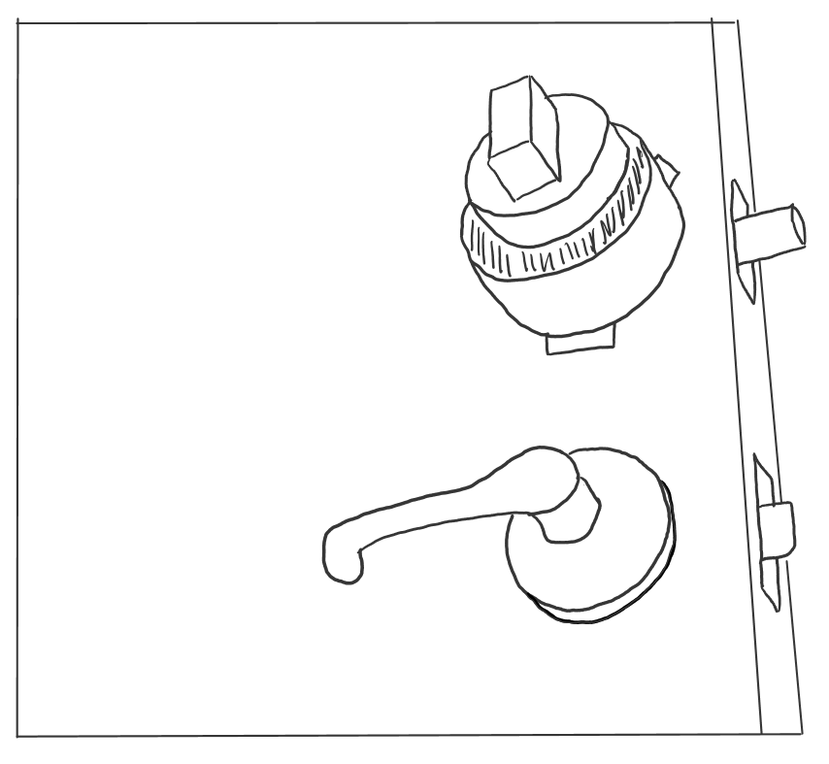
Figure 1. Deadbolt doorknob cover, fitted onto a door lock

Figure 2. Frontal view of the Doorknob Cover
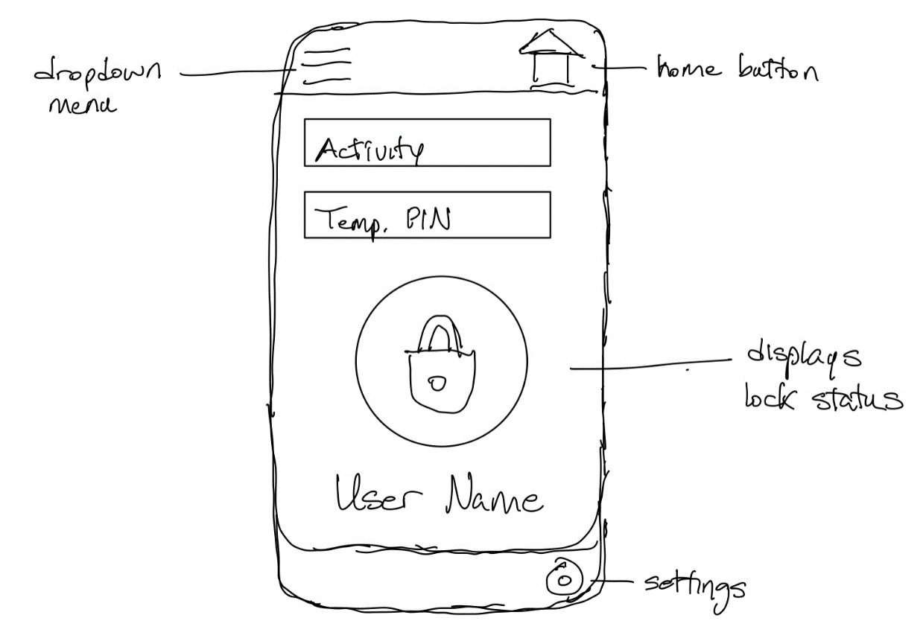
Figure 3. Initial Sketch of Application Main Interface

6 Software Design Details

6.1 Initial Design Architecture
The initial design for the logic of the mobile application is displayed in the flowchart below. When the user first opens the app, they are asked to either log in with their account credentials or create a new account. To create an account, a valid email address is required as well as providing their phone number for alerts. A confirmation email is sent to their account after creating the account, to ensure that the account information is secure. Once they successfully login, the user is sent to the home page and can use the app.

The primary function of this application is the ability to disable the lock via RFID or PIN number. Additionally, the user will be able to access a log of previous lock and unlock attempts by logging in to their account. The application will be available on both Android and iOS, with the iOS version utilizing the facial recognition hardware present in newer iPhones for easier access control.
Another planned feature is the ability to enable GPS proximity unlocking which will track the location of the user’s phone and disable the lock when it is determined that the user is outside the door. This feature is heavily inspired by a similar function of the previously mentioned August Smart Lock, which uses both Bluetooth and GPS technologies to track the user’s device when leaving the house. To protect the user’s privacy, our application will only use this feature once the user enables it.
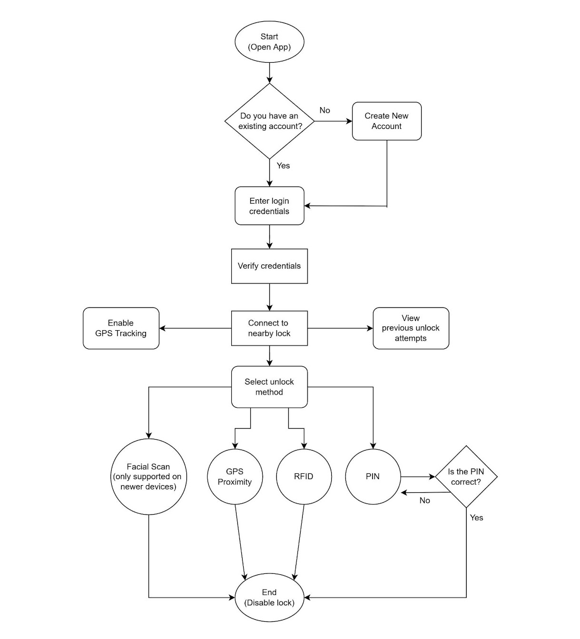

6.2 Mobile Application Pros and Cons
While the decision to include a companion app to Live Bolt was a simple one, there are many kinds of mobile application frameworks to use, each with different combinations of various technologies. This section will give some information on some commonly used full stack applications, as well as any advantages and disadvantages that would come from using those technologies for our application.

6.2.1 LAMP Stack
A LAMP stack is a full stack application comprised of a Linux operating system, an Apache web server, a MySQL database, and can use either Python or PHP as its programming language. Some team members have had experience creating a LAMP stack, so the learning curve would not be as high as opposed to using a more complex stack type. Python as a programming language is very simple to use and has no shortage of support libraries to use. However, Python completely lacks any sort of native mobile framework to use for our application. If we were to use a LAMP stack, we would need to use a framework that has cross-platform functionality such as Kivy or BeeWare. Another problem is the difficulty that comes from using two programming languages when creating the application, Python/PHP for the server-side and JavaScript for the client-side. Switching between two languages can add some unexpected challenges for us on the software end that could be resolved by using a different type of stack.

6.2.2 MERN Stack
On the other hand, a MERN stack uses Node.js as its runtime environment and Express.js as its server-side framework. React is used as the client-side framework with a MongoDB database. Since MongoDB is a NoSQL database, it does not use schemas, but instead stores entries as binary JSON objects. This gives us an additional measure of flexibility when creating our database of users. Using React as the JavaScript library has its benefits as well, with the React Native framework being well suited for mobile development. Since Node.js uses JavaScript for the backend, our team only needs to use a single programming language for our application. This will reduce the time needed to learn any new technologies since anyone with a solid grasp of JavaScript will be able to contribute to the development process. This also applies to Express since it is simply a web framework built off Node.js.

6.2.3 MEAN Stack
A MEAN stack is very similar to the previously mentioned MERN stack but uses AngularJS as its framework instead of React. AngularJS differs from React by being an actual MVC framework, opposed to React simply being a JavaScript library. Instead of using components like React, Angular uses directives to teach the browser new syntax. Angular is also continuously maintained by Google, ensuring that there are many resources at our disposal if we plan to use this framework. Angular also uses HTML in its development process, which some team members already have experience working with. However, this makes the learning curve of Angular much steeper when compared to React, which was designed to only use JavaScript.

6.3 UX Design
When designing our user experience, our team’s philosophy was focused on readability and consistency. Our aim was to create an app that felt like a natural extension of the capabilities of the physical Live Bolt. We initially considered creating a web application instead of a published mobile app in order to save time on development. However, there are many issues to consider when creating a web app meant to be accessed by phones. Since many phones have unique screen sizes, the native web app would have to adjust to every screen size in order to provide consistency. This would be difficult to achieve without using a CSS library that automatically scales UI elements, such as Bootstrap. Even so, our team determined that using a native web app was not worth the tradeoff in customizability. There are many smart lock companion apps on both the Google Play Store and the App Store, so we desired to create an experience that would be immediately recognizable and unique for the consumer.

Even so, original ideas are exceedingly rare to come by. During the design process, our team studied apps of various functions, on both the App Store and Google Play Store. Most, if not all, apps use the same core principles and tools when it comes to the user experience. Above all, apps that are considered to have good UX design are created with the user first and foremost. The user must be able to navigate the app without being confused or overwhelmed by its layout and any interactive elements must be clearly defined such that the user immediately knows that they can interact with them. Adhering to such accessibility principles ensures that users are not excluded from using our app for any reason.

As mentioned in Section 3.1, many smart locks nowadays come with their own companion apps. For example, products such as the August Smart Lock and Nuki Smart Lock have unique mobile apps. These apps usually allow the user to perform the same function of enabling and disabling the lock remotely. Additionally, most apps track the activity of the physical device as a viewable log. Since our team intends to include similar functionality in our mobile application, we have taken inspiration from these kinds of apps to create our own unique user experience.

6.4 Preliminary UI Design
At the beginning of development, our team used Figma to create rough designs for several of the pages for our app. Figma is a web-based graphical tool that can be used to create both app designs and prototypes. Using the free starter level functions, our team was able to come up with a variety of potential user interfaces. Additionally, Figma also has a companion app on iOS and Android that allows users to see how their designs look on phone screens. Some of the initial designs for the login and account creation pages are displayed below.

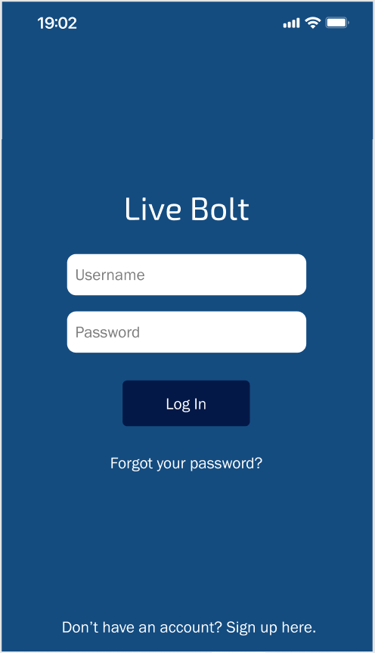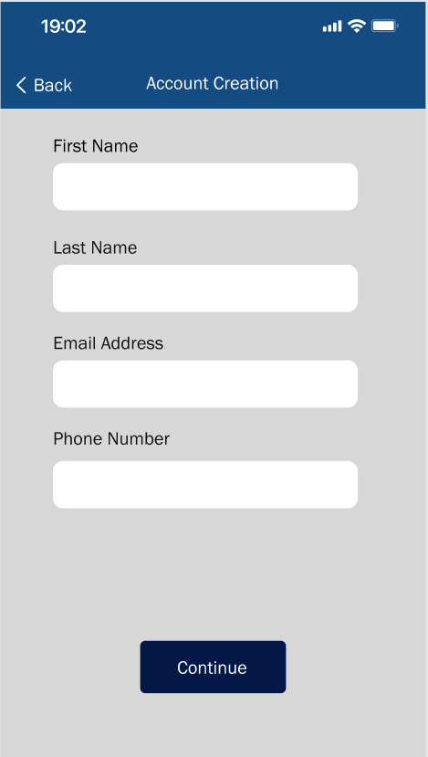


It is important to note that this version of the login page does not include the Live Bolt logo and instead has a placeholder, since the logo was not finalized at the time of creation. The color palette we decided to use for our app was meant to be visually pleasing, yet distinctive enough to make an impression on our users. Blue is a very non-aggressive color for many people and is well rendered on most mobile devices, even on older devices with limited color capabilities. For text rendering, gray works quite well due to its contrast with darker colors without being overly bright and unreadable.

6.5 Logo Design
When creating a logo for any sort of product, the aim is to produce a unique design that reflects the brand or product that is being sold to consumers. Our team sought to create a logo that was simple and appealing in design, while accurately conveying the function of the Live Bolt Smart Lock to consumers. This section will contain several preliminary concepts that were created before our team decided on a final selection. Most of these logos were created using the Adobe Express tool with some slight adjustments made in GIMP.

Insert potential logos here

6.6 Bluetooth Pairing
For a user to connect to a physical Live Bolt lock using the companion app, the app will need to be able to use Bluetooth pairing. According to the Android Developers website, there are three steps when a mobile application seeks to make a Bluetooth connection [2].

- Find nearby Bluetooth devices.
- Connect to a particular Bluetooth device.
- Transfer data with the connected device.

While the website talks about Bluetooth functionality in an Android environment, these steps are general enough to also apply to web and iOS applications. Since data will be transferred between the physical lock and the user’s phone, the connection must be secure to maintain the device’s integrity and security.
Additionally, the GPS proximity feature will use Bluetooth in tandem with the phone’s physical location to automatically disable the lock when the user comes within a set distance. In order to perform these functions, our app will need to use an available plugin or API to get Bluetooth functionality. Since this app is meant to be cross-platform, there are several options that can be used. This section will highlight APIs and plugins that provide Bluetooth functionality, as well as discussing any design choices that were made concerning this subject.

6.6.1 Android Bluetooth APIs
The Android development platform provides several APIs for developers to use when creating applications for the Google Play Store. The development process is further streamlined by having all Bluetooth APIs available in the android.bluetooth package. The Android Developers website includes all the key classes and interfaces needed to implement Bluetooth functionality in any mobile application [3].

6.6.2 react-native-bluetooth-serial Plugin
The React Native framework does not include any native libraries or components for Bluetooth connectivity. Instead, there are a wide variety of 3rd party components that are available to use for mobile developers. Most of the popular components are plugins that have been ported over to React Native, such as the react-native-bluetooth-serial plugin. This component allows React Native applications running on any version past 0.25 to connect to other Bluetooth devices and transfer data. This plugin works for both iOS and Android, however as of the time of writing this paper, services are still not configurable for iOS devices. The GitHub page provides the installation procedure for both iOS and Android, as well as all the methods available for use [4].

6.6.2 react-native-ble-manager Plugin
Another popular React Native component to use for Bluetooth communication is the react-native-ble-manager plugin. The main difference between this component and the previously mentioned one is compatibility with Bluetooth Low Energy (BLE) devices. The Github page details the functionality of this plugin in addition to any events that can be used [6].

6.6.3 Classic or Low Power Mode?
As mentioned earlier in Section 4.1.2, there are two standards of Bluetooth currently in use: Classic and Low Power. Since the physical lock will use the Raspberry Pi 4 to communicate with the user’s phone, the API or component used for Bluetooth functionality needs to be usable with the Pi 4. Fortunately, the Pi 4 is compatible with both Classic and BLE devices.

6.7 Development Environment
When creating a program of any sort, a development environment is needed for programmers to edit and debug their source code in an easy-to-use space. While it is possible to edit code straight from the command line or using a simple text editor, using a development environment allows for us to fix syntax errors and track variables. Nowadays, many integrated development environments (IDEs) also include compliers to debug code.

Due to its simplicity and abundance of native tools for React development, we decided to use the Expo CLI development environment and the Virtual Studio Code IDE for editing source code. Expo CLI is a command line application that can be installed on any terminal of choice and serves as an interface between the developer and the React app. On the other hand, Visual Studio Code (VScode) is a text editor created and supported by Microsoft that is available on Windows, MacOS, and Linux. VScode includes support for both JavaScript and Node.js, making it a very desirable choice for our team. The installation instructions and documentation of both the Expo CLI environment and the VScode IDE are provided in the references section below [5].

6.8 App Store Publishing Process
As with any online platform or marketplace, the Apple App Store has its own unique guidelines and recommendations for developers who seek to publish their apps. Most of these standards are described above in Section 4.1.8 and will be referenced throughout this section. In addition to adhering to proper programming standards, our app must also adhere to the various design, compatibility, and legal standards detailed in the App Store Review Guidelines [6]. After we have determined that our app is fit to be reviewed, we will submit our app along with any metadata via App Store Connect. According to the Apple Developer website, 50% of submitted apps are reviewed in under 24 hours and over 90% are reviewed after 48 hours.

To avoid potential issues with submitting our app for review, we will continuously test and debug our app and ensure that it runs well on all available platforms. Additionally, we will adhere to the App Store’s privacy guidelines by always asking our users for permission to use their data in a clear and understandable manner. To avoid a rushed schedule, we will submit our app well ahead of our planned release date to account for any unexpected issues that may arise during the review process.

6.9 Google Play Store Publishing Process
The publishing process for the Google Play Store differs from the App Store process in several ways. The platform used for publishing to the Play Store is Google Play Console, which is used for development, review, and publishing. In order to start the review process, we must first publish a draft version of the application. To proceed to the review stage, the app must not have any detected errors. Just like the App Store process, our app will be rigorously tested to ensure that our users will not encounter bugs or crashes.

Additionally, there are two types of publishing our app can undergo: standard publishing and managed publishing. Standard publishing allows any updates or changes to all existing apps, with a waiting period of up to 7 days for review. Managed publishing lets the developer control where any changes are published after their app has been successfully cleared for release, allowing for greater version control over the standard method. The Google Play Console Help page also details every possible status for an app or update [7]. Since we are planning for a cross-platform release, we would like our app to be reviewed and given the status for production in order to ensure that both releases occur in the same timeframe.

6.10 Mobile Stack Technologies
After researching and analyzing various stack types, those of which were mentioned in Section 6.2, our team eventually decided what stack application our mobile app would be. This section details the reasons behind our decision, as well as any technologies being used that have not been mentioned so far.

6.10.1 MERN Stack Reasoning
Ultimately, we chose to create our application using a MERN stack for a variety of reasons, many of which are described above in Section 5.6.2. As mentioned earlier, a MERN stack comprises of a MongoDB database, a Node web server, an Express web framework, and a React client-side. Since most of our team has a measure of familiarity with developing a MERN stack in previous classes, namely in Processes of Object-Oriented Development, there will not be as much learning required in order to create our app using a MERN stack.

6.10.2 JavaScript
JavaScript, along with HTML and CSS, are the main building blocks for any kind of web application. It is a high-level language, along with languages such as C#, Ruby, Python, and Java. It is important to maintain that Java and JavaScript are completely separate languages, though they share similarities in syntax. JavaScript is also incredibly popular, with over 97% of websites using the language client-side for web page behavior [8]. This code usually executes client-side to load new pages, generate user results, and control web page animations. The amount of JavaScript libraries is incredibly large and several of them control large parts of the web development process. Many of them will be used in our app which are further explained upon below.

6.10.3 Ajax
While Ajax is not a library, it is an important technology that is often used in web development. Short for Asynchronous JavaScript and XML, it is the method the XMLHttpRequest object uses to communicate with the web server. Most important about Ajax is its ability to operate asynchronously, meaning that it can exchange data and update a web page without needing to reload the page. Additionally, the data that is sent and received can be in several formats, including JSON, XML, and even text files [9]. The Mozilla Developers website contains the documentation of Ajax, along with an introductory article through which most of this data was taken from.

6.10.4 jQuery
jQuery is a cross-platform JavaScript library that simplifies Document Object Model (DOM) traversal and manipulation. A DOM is an interface that converts an XML or HTML document into a tree structure, allowing a web page to be dynamically generated via JavaScript code. jQuery also boasts Ajax functionality which is used by the XML object to effectively communicate with the web server. It is important to note that there is a version of jQuery made to work with mobile devices, called jQuery Mobile. Unlike the standard jQuery API, jQuery Mobile is a complete UI framework, which means it needs to be built upon as a starting point. This conflicts with our preference towards using React Native as a framework, so this prevents us from fully using the jQuery Mobile API. For this reason, we will only be using version 3.6.0 jQuery API for our mobile application.

6.10.5 JSON
JavaScript Object Notation (JSON) is a data-interchange format based on the conventions of the JavaScript programming language. While it does use much of the syntax used in JavaScript, JSON is completely language-independent and can be used with any programming language, though it commonly sees uses in high-level object-oriented languages. JSON usually is comprised of two kinds of data structures: a collection of name/value pairs and an ordered list of values. In most programming languages, these are both realized as arrays or lists. Due to its simple and effective structure, JSON is used for all sorts of data transfer operations in web development.

6.10.6 JSX
JSX is simply a syntax extension of JavaScript that is commonly used with React. Though it contains elements of HTML syntax, JSX still has all the benefits of JavaScript without sacrificing the benefits of a template language such as HTML or CSS. The main function of JSX is to produce React elements, which are the main building blocks of any React application. JSX uses rendering in order to implement React elements into browser DOMs, which has several advantages over the traditional method of DOM traversal and manipulation. Unlike browser DOM objects, React elements are plain objects and much cheaper to make. These developer-created elements work together to form React components, which can be described as the React equivalent of JavaScript functions. Like a function, these components accept certain properties (or props) as parameters and generate a React element to be used in the user interface. These components can be used in other React applications in the same way a JavaScript function can be used in a different program.

6.10.5 JSON Web Token
With our mobile application having several technologies communicating with each other, it is important to also maintain data integrity during the development process. JSON Web Token (JWT) is an open standard that defines a compact way for securely transferring information between entities as a JSON object [reference needed]. There are many reasons to use JWT as a method of securing data, such as verifying the identity of a sender or recipient of data and authorizing specific users to use an application.

The structure of a JWT consists of three parts: a header, payload, and signature. The header contains the token type and algorithm, which in most cases would be JWT and a standard signing algorithm such as HMAC SHA256 respectively. The payload usually contains information concerning the user and the type of claim being made. Lastly, the signature ensures that none of the contents of the token were altered in any way. The result after encoding is three URL strings separated by dots, a format that is easily passed through in HTML and HTTP settings.

6.11 Database Structure
The database our application will use will need to contain several types of user data including logins, passwords, user activity, emails. It must be structured in a manner that our app will be able to efficiently search for any information it needs at a moment’s notice. A well-designed database typically has the following traits [18]:

- Efficient access to data
- Supports long-term maintenance of data integrity
- Clean and consistent structure
- Avoids redundant storage
- Accurately reflects the structure of the problem

To create a database with these principles in mind, our team first created a preliminary entity relationship diagram of the database. An entity relationship diagram (ERD) is used to map out the structure and relationships present in the database. Outlining an ERD before designing the actual database comes with many benefits to the overall creation process. For example, making changes with an ERD is far easier than having to modify the database’s data directly, especially since adjusting data can be very risky as the scale of the database increases. Additionally, the creation of a visual aid helps with keeping track of all the needed data in one easy-to-read diagram, which makes it useful for gathering requirements and specifications. The ERD modeling of our database is shown below, complete with variable types and entity relationships.

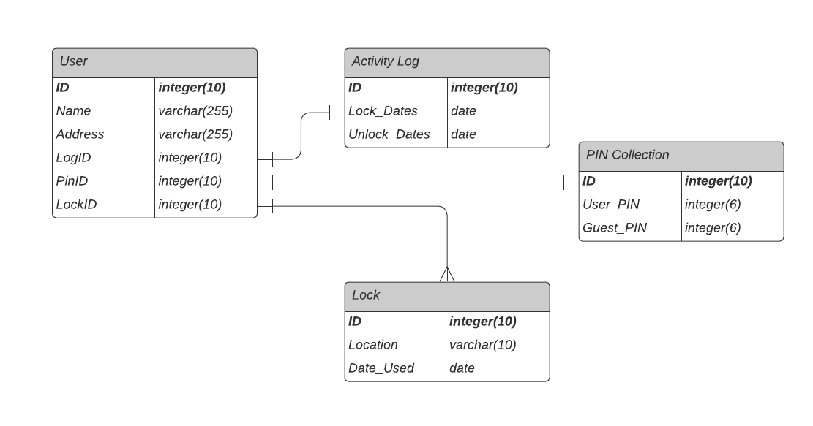
As shown above, the database for our companion app consists of four entities: users, activity logs, PIN collections, and locks. A user entity contains relevant information such as their name and address, as well as a unique ID. The user entity also has three foreign keys which reference an activity log, a PIN collection, and a Lock. It is important to note that all attributes in bold are primary keys, all of which are IDs in the case of this database. The data type is also listed next to its corresponding attribute, mostly comprising of integers and character strings. Of course, this diagram was made early in the project so changes may need to be made as development progresses.

6.11.1 MongoDB Syntax

7. Hardware Design Details

7.1 Electronics Placement
After researching and having the desired parts selected, it is essential to organize the electronic placements for our design. From our objective, we plan on having wireless intercommunication between the lock and security system. Since we’ve decided to work with two aspects for our project, this design will have to be split into an indoor and outdoor design where they will respectively unlock the door and provide home monitoring.

7.1.1 Dead Bolt Lock Prototype
Since this project is designed specifically to use a dead bolt lock, we need to integrate hardware to perform the locking/unlocking sequence at the command of the consumer. To meet our objective for the project, we will also keep the design of the lock as minimal and compact as possible.

There’ll be three main components that’ll be harnessed onto the deadbolt design: high-torque standard servo motor, 5V battery pack, and an ESP8266. The servo will oversee turning the knob in the dead bolt; the 5V battery pack will supply power to the servo motor and ESP8266; and the ESP8266 will be the wireless connection to command the servo to unlock/lock the door.

With these parts solidified, we’re going to design a lightweight box to harness the electronics from collecting the dimensions from the following parts. Within the box, we not only have all the electronics but, we’ll have a 3D printed knob case to turn the lock and separation compartments to access the hardware. Additionally, there’ll be a cut in the box to shape the dead bolt lock and hold the compartment to the door. A better representation of the box design is shown in Figure 4.

All dimensions of the electronics are taken into consideration when designing the length, width, and dead bolt diameter in the box. The customer will see a an 100x80 mm box with flushed corners to create an aesthetic design. The depth of the box will be determined after collecting the dead bolt and servo motor depth. The battery and ESP8266 will have enough space to fit comfortably in the box. How we plan to organize the component in the box will be shown in the free draw sketch in Figure 5. This sketch is not to scale and will be modified to a more compact lock design.

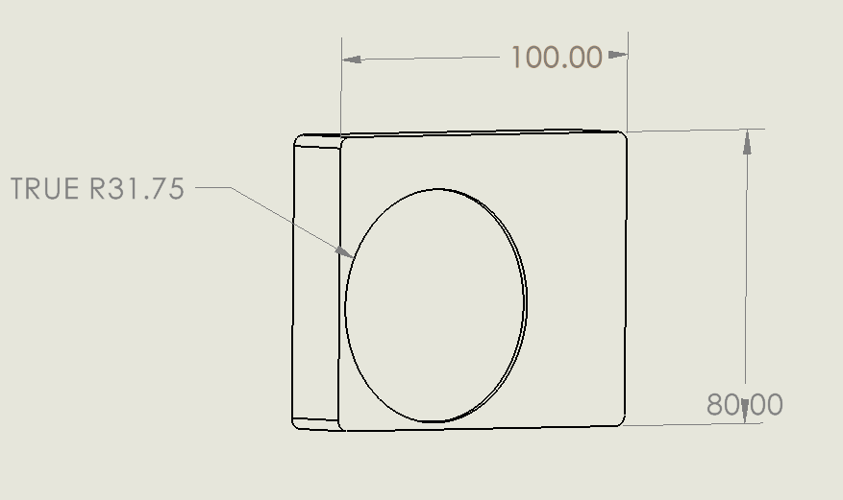
Figure 4. Lock box design to harness electronic components

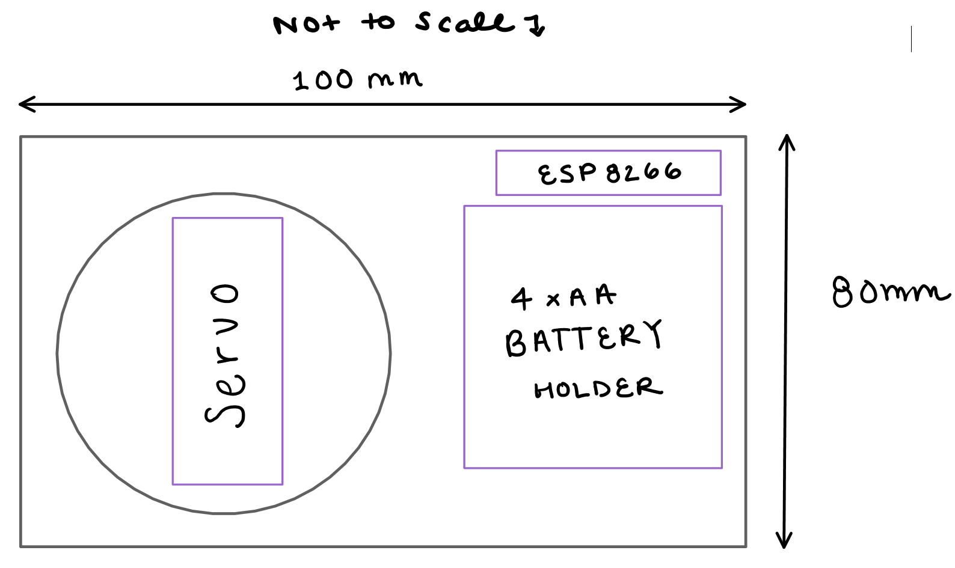
Figure 5. Lock box sketch with electronics

7.1.2 Security Prototype
The security prototype design for Live Bolt will be built to accommodate the electronics to compensate with the demand we require for home monitoring, home entrance, and wireless update to the application. To complete this objective, we narrowed down all the electronic parts, required to perform those actions, along with collecting their dimensions to comprise all the settings into a compact security system.

The outside perspective that’ll be viewed by the customer will be a 155x72 mm box with cuts to represent the positions for the Raspberry Pi Arducam, PIR motion sensor, and Arduino keypad. The most interactive aspect outside of the box will be the keypad. User can see and physically interact with the keypad for home entrance. The keypad will tailor towards the use of guests and delivery works as a one-time entrance which can be configured in the application. The Arducam and PIR motion sensor will be the security portion of the project. Their objective is to monitor and relay information about front door activity to the application. Including these components to our design will cover security object in our project.

Within the Live Bolt box, we will include a Raspberry Pi 4, Arduino Uno, NFC Reader, Raspberry Pi Microphone, and a rechargeable battery component. In Figure 7, the box was design to equate the size of the microcontrollers in parallel to compensate the needs for the electronics, e.g., Arducam and PIR motion sensor. One thing to note that is missing from Figure 7 is including the design for the rechargeable battery. Since this portion of the project is still under review, it is still something we considered when designing the box. The width of 50 mm, as shown in Figure 6, will be the buffer area for including the rechargeable battery and possible integration of a PCB. Additionally, the design shown in Figure 6 is a representation of what can be placed onto the compartment without the idea of being enclosed. The design for closing the box and mounting it onto a wall is to be determined along with easy access to recharging. Note that the design is a prototype and currently not to scale.

The interactive portion of the box that is not viewed by the customer is the access to speech detection. Using a Raspberry Pi Microphone and relaying speech detection to the raspberry pi is way we wanted to incorporate access control to the customer. Since this microphone is flushed into the box, security breach from speech detection will be lowered since there is no outside acknowledgement of an entrance code.

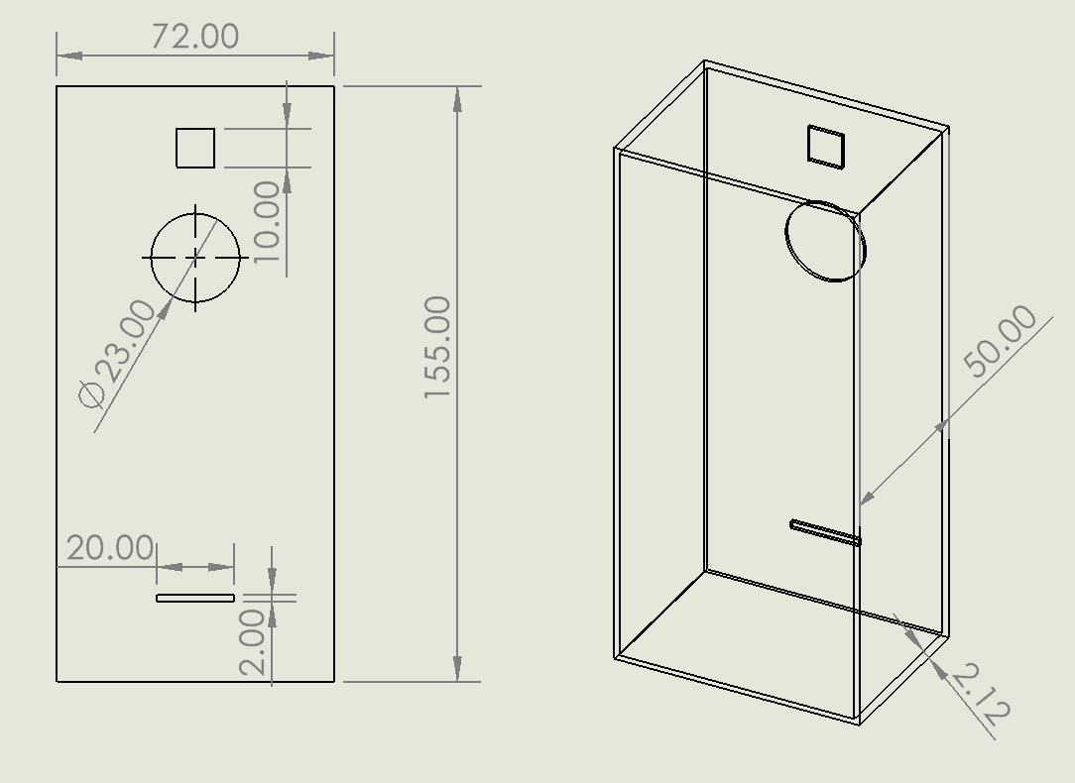
Figure 6. Security Box design to harness electronic components

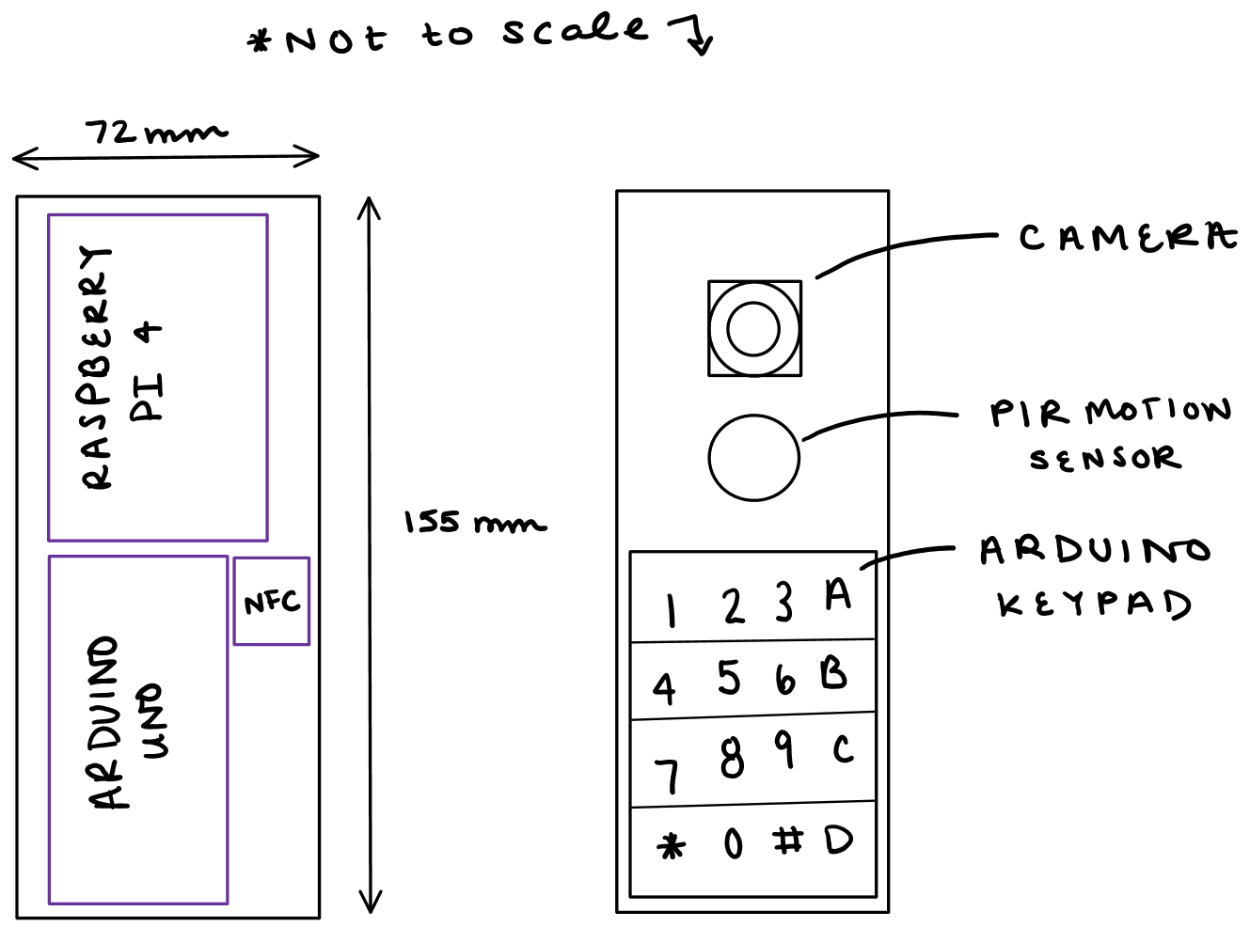
Figure 7. Lock box sketch with electronics

7.2 Power Distribution
Our system is complex in the sense that each component will require a voltage input to keep the system running. Since our design requires microcontrollers, sensors, WiFi module and a servo, it’s essential to make sure that each respective component will function properly and run given the power source provided. Before determining a power distribution system, collecting data of the operating voltage for each component would create value. Table 6 below is a list of the components used and their voltage requirement. Based on the data collected, we will create a 5V battery pack to place onto the lock box and possibly including a 12V rechargeable battery onto the security box to compensate the total required power distribution.

Table 6: Component Power Requirements
COMPONENT SECTION | POWER REQUIREMENT | LOCATION OF HARDWARE
Sensors
Raspberry Pi Microphone | Source from Raspberry Pi | Security
Arducam | Source from Raspberry Pi | Security
Motion Sensor IR Detector | 4.5 – 20 V | Security
NFC Reader | 2.7 – 5.5 V | Security
Microcontrollers
Arduino Uno | 7 – 12 V | Security
Raspberry Pi 4 | 5 V | Security
Microchip
ESP8266 | 3.3 V | Lock
Servo Motor
High Torque – Metal Gear | 5 V | Lock

7.3 3D Printing
The deadbolt and security box can be created built through different aspect of materials. However, from our objective we want to ensure that Live Bolt is a lightweight portable product. Hence the choice of creating our prototype box will be from 3D printed filament.

Choosing the right filament to create a durable design and withstand temperature is at our highest priority. We want to make sure that the customer is obtaining a log lasting and eco friendly product. Hence, we will narrow down the choice of using PLA filament for ease of printing quality, temperature withstand, and pricing.

Some qualities PLA filament includes is strength quality of 119 – 184 pounds; it’s ability to stand with cold and hot temperatures without crack; and its ability to be recyclable after usage. PLA filament is recommended to not be used outside where it is faced through UV rays or moisture; however, since this is a prototype and we’re limited to manufacturing materials, it’s best to showcase our design first from an enclosed box and later incorporate durable outdoor material. Choosing a PLA filament for the dead bolt design doesn’t seem to be a problem since it won’t be over exposed to UV radiation or drastic temperature change.

7.4 Summary of Design

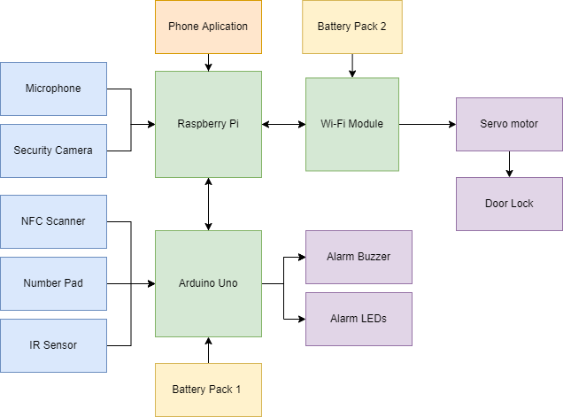
Figure 8. Hardware Design Block Diagram

8. Printed Circuit Board Integrated Schematics
To achieve a concise and compact final product, a printed circuit board will need to be designed after the breadboarding phase of the project is complete. This section will outline all aspects of the PCB design process as well as the ordering and assembly.

8.1 PCB Terminology
Table 7 provides some common terms and abbreviations regarding PCB terminology and what they mean.

Table 7: Common PCB Terms
Term | Explanation
CAD | Computer-aided Design. This refers to the software used to design a PCB.
Component | Components are what make up the circuit of the PCB. They get attached to the board after it is designed and printed.
Copper | Copper is a conductive metal that laminates most PCBs
DRC | Design Rule Checks are an automated process ran by the CAD software to ensure the PCB is ready to be printed. They find potential errors such as holes or traces being too close together, or errors in the circuitry.
Footprint | A footprint is a digital representation of a component that acts as a placeholder while designing the PCB. Usually, footprints have the component specifications like size to ensure everything fits properly on the board.
FR-4 | The most common material PCBs are made of. It is a glass reinforced epoxy resin.
Gerber FIle | Gerber Files are files of the PCB that outline each layer of the design. They are sent to vendors who will print the board.
IC | Integrated Circuits are chips that house very small circuits that help to keep the overall PCB organized and neater. ICs have many uses and applications, from voltage regulators to timers and more.
Pad | A pad is a conductive spot for components to be soldered to the board.
Silk Screen | The silk screen is a nonconductive layer on the board, usually reserved for logos or words. It is useful to label specific spots in the silk screen to refer to them during assembly.
SPICE | Simulation Program with Integrated Circuit Emphasis is a program that allows for virtual simulation of circuits and the ability to measure their outputs.
Solder Mask | Solder Mask is a nonconductive layer that covers most of the board. It insulates copper traces to negate shorting of the circuit.
SMT | Surface Mount Technology is a way to connect components to the board. Surface mount components are rested on pads and soldered directly to the board. Most consumer electronics rely on SMT.
Through Hole | This is the alternative to SMT and refers to the leads of electrical components being passed through holes in the PCB and soldered into it. This method uses up more space but is usually easier to do.
Trace | Copper traces are what conducts the electricity between each component. They are etched into the solder mask so that only the underlying copper remains.
Via | A via is a conductive hole in a PCB that can connect different layers of the board, such as components on the top of the board connecting to components on the bottom of the board.

8.2 PCB CAD Software
There are many computer-aided design (CAD) tools that allow for the design and testing of printed circuit boards. The two that we are considering for this project are KiCad and Autodesk EAGLE.

8.2.1 KiCad
KiCad is a free design suite for designing and simulating printed circuit boards that was developed in 1992. Since it is free of cost, there is a variety of tutorials and resources online. This makes the learning curve for KiCad much better for new designers. It offers Simulation Program with Integrated Circuit Emphasis (SPICE) simulation, open-source footprint libraries, and a 3D-view of the PCB once it is designed.

8.2.2 EAGLE
EAGLE, designed by Autodesk in 1988, is another CAD software for PCB design. EAGLE stands for Easily Applicable Graphical Layout Editor. Unlike KiCad, it is not free and instead offers a subscription-based model. However, University of Central Florida students get Eagle for free with their student emails. Since EAGLE is closed source, there aren’t as many online resources and customization options, and it is a bit harder to start using when compared to KiCAD. EAGLE was used as the CAD software of choice in the EEL 3926L Junior Design course at UCF, so students do have some experience with it. EAGLE also offers the option to collaborate with others on a single design and dynamically update the design.

8.2.3 CAD Software Decision
Due to the advantages like collaboration, being free of charge, and having past experience, the team has decided to create our circuit and PCB design in Autodesk EAGLE.

8.3 PCB Vendor and Assembly
The process of getting a PCB printed is simple. Once the design is completed, the gerber files should be exported and sent to a vendor. Once they have the gerber files, the number of layers, size of the board, thickness, color, and quantity are all defined. There are numerous vendor options online to get a PCB printed and mailed.

The option we are going to pursue will be JLCPCB due to having positive experiences with them in the past for printing PCBs. Depending on the size and complexity of the board, they offer prices as low as $2 for 5 boards, excluding shipping. They also offer PCB surface mount assembly, since the process for surface mount soldering is more complex than through hole.

9. Project Prototype Testing Plan

9.1 Hardware Test Environment

9.2 Hardware Specific Testing

9.3 Software Test Environment

9.4 Software Specific Testing

10. Administrative Content

10.1 Milestone Discussion
In Table 8, and Table 9, shown below detail our plans of researching and completing our senior design project. focuses on our milestones we will be working on in Senior Design I while lists our milestones for Senior Design 2. The milestones column lists the tasks we are trying to accomplish during each semester. The duration column lists the number of weeks we will devote to each milestone. The dates column lists the deadlines we must complete the milestone by to keep on track. Some of the dates in are tentative as we do not know the exact dates, we will need to complete milestones that far into the future. As we continue working on and researching our project, we plan to revisit these milestones frequently.

Table 8: Senior Design 1 Milestones
Milestone | Duration | Dates
Brainstorm | 1 Week | January 14
Select Project | 1 Week | January 21
Divide and Conquer | 2 Weeks | February 4
Research | 4 Weeks | March 4
Table of Contents | 1 Week | March 11
60 Pages Due | 2 Weeks | March 25
Edit Draft | 3 Weeks | April 15
Finalize Report | 1 Week | April 22
Submit Final Report | 1 Week | April 29

Table 9: Senior Design 2 Milestones
Milestone | Duration | Dates
Source Remaining Parts | 2 Weeks | September 2
Build Prototype | 4 Weeks | September 30
Test and troubleshoot | 3 Weeks | October 21
Finalize Prototype | 3 Weeks | November 11 (Tentative)
Final Report | 2 Weeks | November 25 (Tentative)
Final Presentation | 1 Weeks | December 2 (Tentative)

10.2 Budget and Finance Discussion
A goal is to make Live Bolt as cost-effective as possible while maintaining quality in the build and design. Table 10 outlines the parts we have identified for the product and their costs. Most items are marked as 2 needed, so there will be backup components in case any malfunction. The price per single unit and total price are both listed. Items marked as $0 indicate that the team already has them, so there is no need to include those costs in the final price. The final row also provides the total cost of all components and the amount of money each member of the group will contribute.

Table 10: Bill of Materials
Part Description | Qty Needed | Price/Unit | Estimated Total Price
Raspberry Pi 4 | 2 | $40 | $80
Assorted Wires, LEDs, Buzzer, and other electrical components | - | $0 | $0
Camera | 2 | $15 | $30
Pin Pad | 2 | $0 | $0
NFC Reader | 2 | $9 | $18
IR Motion Sensor | 2 | $8 | $16
Raspberry Pi Microphone Array | 2 | $29 | $58
Arduino Uno | 1 | $0 | $0
High Torque Servo | 2 | $20 | $40
Lock Battery Holder | 1 | $2 | $2
Security Battery holder | 1 | tbd
ESP8266 | 2 | $0 | $0
PCB Printing | - | tbh
Door Knob and lock for Testing | 1 | $0 | $0
Total Members | 4 | $61.00 | $244

Appendices

Appendix A – References

References

[1] | [Online]. Available: https://www.biometricupdate.com/202001/biometric-facial-recognition-hardware-present-in-90-of-smartphones-by-2024.
[2] | [Online]. Available: https://www.ieee.org/about/corporate/governance/p7-8.html.
[3] | [Online]. Available: https://developer.android.com/guide/topics/connectivity/bluetooth.
[4] | [Online]. Available: https://github.com/rusel1989/react-native-bluetooth-serial#events.
[5] | [Online]. Available: https://code.visualstudio.com/docs.

[5] [Online]. Available: https://docs.expo.dev/
[6] [Online]. Available: https://developer.apple.com/app-store/review/guidelines/#performance
[7] [Online]. Available: https://support.google.com/googleplay/android-developer/answer/9859751?hl=en#zippy=%2Capp-status
[8] [Online]. Available: https://w3techs.com/technologies/details/cp-javascript/
[9] [Online]. Available: https://developer.mozilla.org/en-US/docs/Web/Guide/AJAX/Getting_Started
[10] [Online]. Available: https://www.geeksforgeeks.org/coding-standards-and-guidelines/
[11] [Online]. Available: https://play.google.com/about/developer-content-policy/
[12] [Online]. Available: https://developer.apple.com/app-store/guidelines/
[13] [Online]. Available: https://www.nist.gov/osac/facial-identification-subcommittee
[14] [Online]. Available: https://www.lifewire.com/wireless-standards-802-11a-802-11b-g-n-and-802-11ac-816553
[15][Online]. Available: https://www.doorware.com/specials/help-center/deadbolt-guide.cfm
[16][Online]. Available: http://nearfieldcommunication.org/technology.html
[17][Online]. Available: https://www.digi.com/solutions/by-technology/bluetooth-standards
[18][Online]. Available: http://web.mit.edu/11.521/www/lectures/lecture10/lec_data_design.html

Appendix B - Datasheets (if needed)

Appendix C – Software (if needed)

Appendix D – Other

